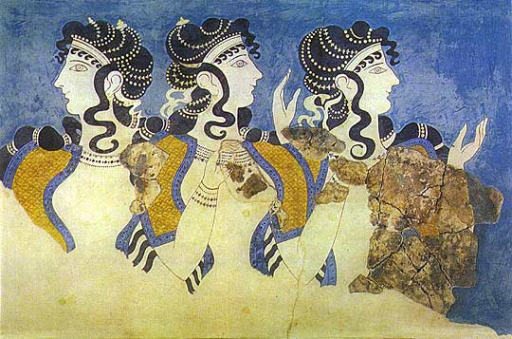
SIRAGUSA TOURS LTD
Art History and Classical Studytours

Newsletter, Autumn 2011
Study Tour Programme

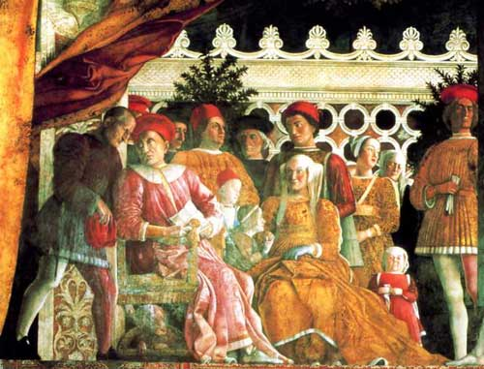 | 27 October – 3rd November 2011  The Renaissance Courts of Mantua, Ferrara & Urbino  led by Daphne Joynes  Course Cost £810 (plus flight)  OU related courses: AA305/AA315/A216/General Interest  VIABLE MORE PLACES AVAILABLE
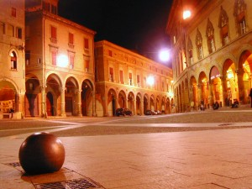 | 4 – 7 November 2011  LRAC Bolgona, led by Mary Hawkins  Course Cost LRAC members £435, non-members £455 (plus flight)  OU related courses: AA305/L195/General Interest  FULLY BOOKED, but contact us to be put on waiting list
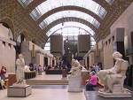 | 18 - 21 November 2011  Paris: Modern Art  led by Jackie Parry  Course Cost £505 (including Eurostar)  OU related courses: AA318/A216/General Interest  VIABLE MORE PLACES AVAILABLE
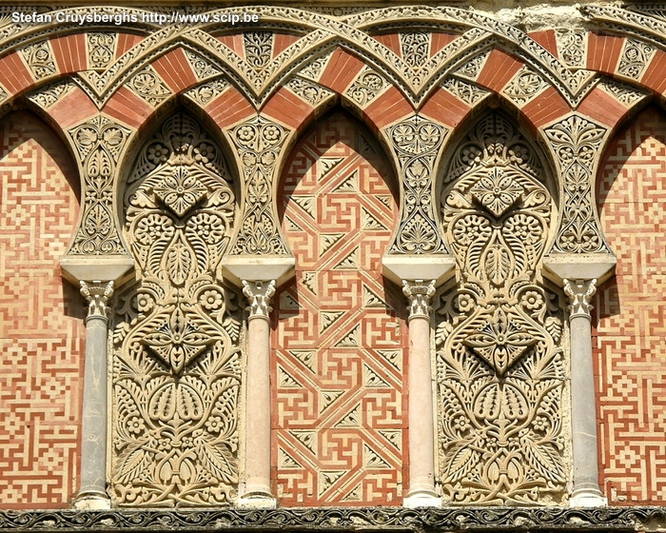 | 20 – 27 November 2011  Granada, Cordoba & Seville: In the Steps of the Moors  led by Mary Hawkins  Course Cost £745 (plus flight)  OU related courses: General Interest  FULLY BOOKED, however, if you are interested please let us know anyway so that we can get in touch if places become available again
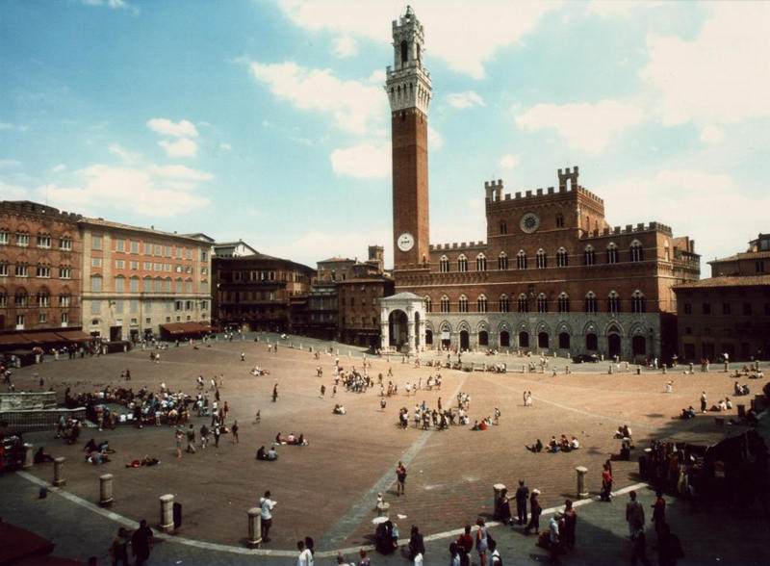 | 1 – 5 March 2012  Siena & San Gimignano: Art and Culture  led by Daphne Joynes  Course Cost £560 (plus flight)  OU related courses: General Interest/AA315/A216  VIABLE, 4 PLACES LEFT
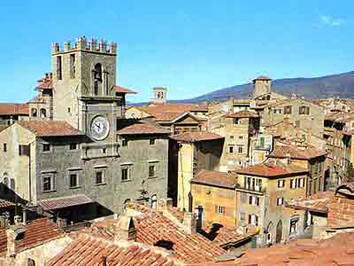 | 6 - 12 March 2012  Cortona, Assisi and Arezzo, half board basis (on 4 of the nights)  Led by Mary Hawkins  Course Cost £870 (plus flight)  OU related courses: General Interest/AA315
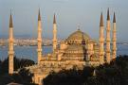 | 19 – 25 April 2012  LRAC Istanbul  Led by Dalila Castelijn  Course Cost LRAC members £725, non-members £745 (plus flight)  OU related courses: General Interest  VIABLE, MORE PLACES AVAILABLE
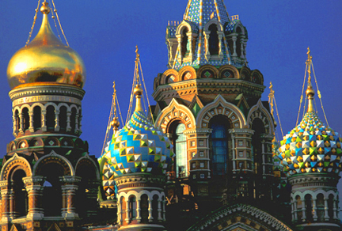 | 9 – 14 May 2012  St Petersburg  Led by Mary Hawkins  Course Cost £895 (plus flight and VISA)  OU related courses: General Interest
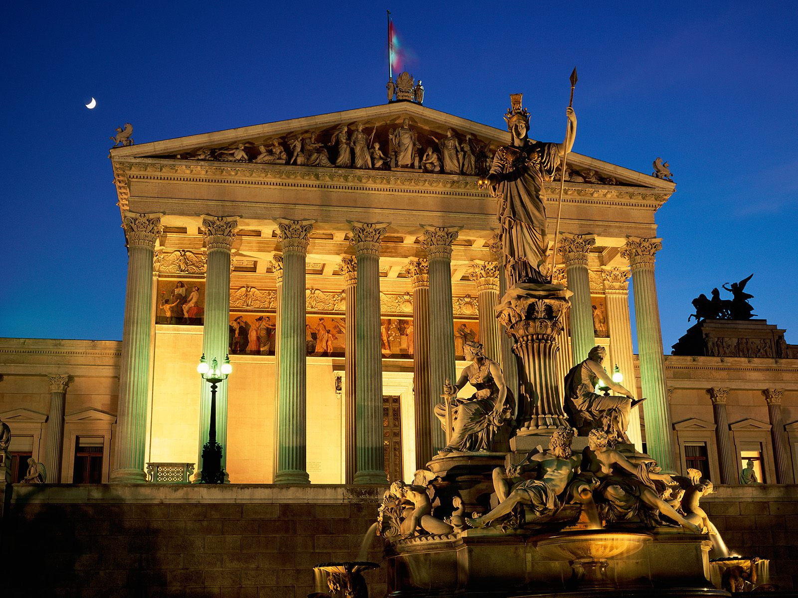 | 24 – 28 May 2012  Vienna  Led by Jackie Parry  Course Cost £575 (plus flight)  OU related courses: General Interest
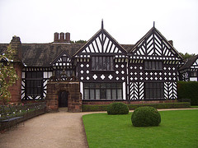 | 28 June – 1st July 2012  Liverpool  Led by Jackie Parry  Course Cost £315 (plus train)  OU related courses: General Interest/A216/AA315

NEW LRAC TOUR, Istanbul, 19 – 25 April 2012, led by Dalila Castelijn
The tour is viable and there are more places available. To secure a place get in touch quickly

ST PETERSBURG, 9 - 14 May 2012, led by Mary Hawkins
We need a few more bookings to make this tour viable, if you are interested please get in touch quickly.

TOURS LATER IN 2012
Trentino & Verona, led by Dalila Casteljin, 6 – 12 September 2012
Paris, led by Jackie Parry, November 2012
Malta, led by Mary Hawkins, 21 – 26 November 2012
Florence, led by Daphne Joynes, 3 – 8 December 2012
Get in touch to express interest.

NEW GALLERY VISIT, 26 May 2012, with Mary Hawkins

FASCINATING FACES - When we meet someone, the first thing we do is look at the face - and the same applies when we look at paintings of people, both portraits and narrative scenes. It's impossible to escape from faces in the paintings in the National Gallery, and in them we look for clues to mood and character to help us identify the thoughts, feelings and experiences of those portrayed.

The portrayal of people not only tells us something about the character and status of a sitter in a portrait, or the dramatic situation in a narrative, but also of the aims, influences and preoccupations of those who painted them. And this raises questions concerning how a face can suggest a character and how and why artists portray people, both saints and sinners, in the way they do.

During our visit we shall explore some of these fascinating issues amongst a sea of fascinating faces!

Gallery and Museum Visits

22 Oct  2011 | Myth in the Greek World,  British Museum, London | A330/General Interest | Dr Sue Blundell | 11:00 – 13:00 | £17.50
22 Oct 2011 | Myth in the Roman World,  British Museum, London | A330/General Interest | Dr Sue Blundell | 14:00 – 16:00 | £17.50
28 Jan 2012 | Making Renaissance Art: Craftsmanship and Technique in early Italian Painting, NG | AA315/A216/  A840/General Interest | Daphne Joynes | 11:00 – 13:00 | £17.50
11 Feb 2012 | From Early to High Renaissance: Continuity and Change in Italian Painting, National Gallery | AA315/A216/  A840/General Interest | Daphne Joynes | 11:00 – 13:00 | £17.50
18 Feb 2012 | Renaissance Altarpieces, National Gallery, London | AA315/General Interest | Mary Hawkins | 11:00 – 13:00 | £17.50
18 Feb 2012 | Netherlandish Painting, National Gallery, London | AA315/General Interest | Mary Hawkins | 14:00 – 16:00 | £17.50
10 March 2012 | The Wallace Collection: An International Treasurehouse (18th Century French Painting) | A216/General Interest | Jackie Parry | 11:00 – 13:00 | £17.50
10 March 2012 | Impressionism, National Gallery London | AA318/General Interest | Jackie Parry | 14:30 – 16:30 | £17.50
24 March 2012 | Different Views of Art: Patronage in Italy Outside Florence  National Gallery, London | AA315/A216/  A840/General Interest | Daphne Joynes | 11:00 – 13:00 | £17.50
21 April 2012 | Topics for Projects and Independent Essays,  National Gallery, London | AA315 | Daphne Joynes | 11:00 – 13:00 | £17.50
28 April 2012 | Victorian Painting, Tate Britain, London | A216/General Interest | Jackie Parry | 11:00 – 13:00 | £17.50
28 April 2012 | PreRaphaelite Brotherhood, Tate Britain, London | A216/General Interest | Jackie Parry | 14:00 – 16.00 | £17.50
12 May 2012 | Cubism to Abstraction, Tate Modern, London | A216/AA318/General Interest | Jackie Parry | 11:00 – 13:00 | £17.50
12 May 2012 | New, Newer, Newest: Conceptualism and After, Tate Modern, London | A216/AA318/General Interest | Jackie Parry | 14:00 – 16:00 | £17.50
26 May 2012 | Fascinating Faces: A Study of Portraits, National Gallery, London | General Interest/A216 | Mary Hawkins | 11:00 – 13:00 | £17.50

TUTORS: The tutors for these Gallery and Museum Visits are all experienced Lecturers who have been selected for their skills in communication and teaching. They are able to direct attention to study issues whether at an introductory or advanced level. Siragusa Tours Ltd reserves the right to substitute a named tutor. Tutors/Lecturers will be identified by a badge displaying their name.

GROUP SIZE: For Gallery/Museum Visits the number of participants will usually be no more than 15. This is to ensure the maximum benefit for all participants.

CANCELLATIONS: If Siragusa Tours Ltd is obliged to cancel a particular Gallery/Museum Visit, a full refund will be made. If you are unable to participate and cancel before the event you will receive a voucher to be used at another similar event or you can choose an alternative visit.

MEETING POINTS FOR GALLERY VISITS
National Gallery: ‘Meeting Point’ beside the Information Desk in the Sainsbury Wing
National Portrait Gallery: By the entrance
V&A: Group Entrance in Exhibition Road
Courtauld Institute (Somerset House, The Strand): Under portico outside gallery entrance
Tate Modern: In the Turbine Hall by the Information Desk
Tate Britain: Manton group entrance on Atterbury Street
British Museum: In the Great Court by the Information Desk
Estorick Collection: By the entrance

Siragusa Tours Ltd, Unit 26, JBJ Business Park, Northampton Rd, Blisworth, Northants NN7 3DW
Tel 01604 859491 Fax 01604 858511 info@siragusatours.co.uk www.siragusatours.co.uk

----------------------------------------------------------------------------------------------------------------------------------------------
Gallery and Museum Visits Booking Form

Mr/Mrs/Ms
Address
 |  | Post Code
Phone | Mobile
E-mail
OU Course(s)
Date | Time | Location | Course | Places | Total
 |  |  |  |  | £
 |  |  |  |  | £
 |  |  |  |  | £
 |  |  |  |  | £
 |  |  |  |  | £
 |  |  |  |  | £
 |  |  |  |  | £

I enclose a cheque made payable to Siragusa Tours Ltd for £

