SIRAGUSA TOURS LTD

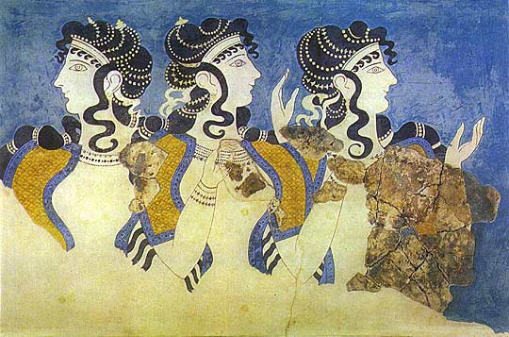
Art History and Classical Studytours

Newsletter, February 2013

Study Tour Programme

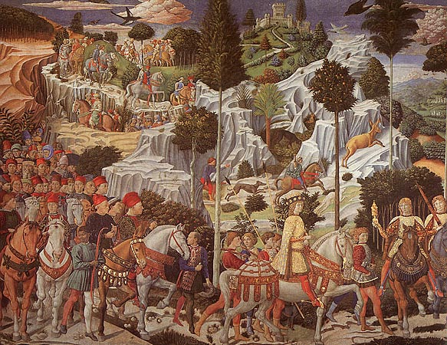 | 27 February – 4 March 2013  Renaissance Florence and Fiesole  Led by Daphne Joynes  Course Cost £545 (plus flight)  OU related courses: AA315/A226/General Interest  VIABLE
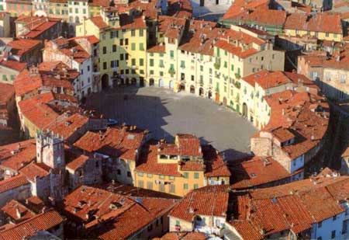 | 10 – 15 April 2013  Lucca, Puccini and the Merchant of Prato  Led by Mary Hawkins  Course Cost £590 (plus flight)  OU related courses: AA315/A226/General Interest  FULLY BOOKED
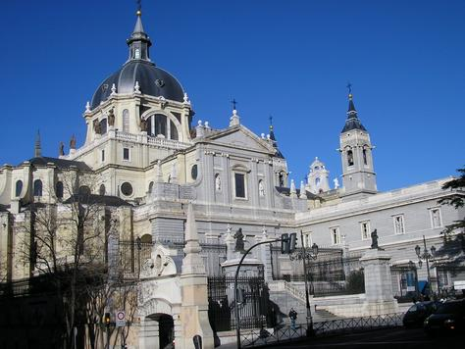 | 9 – 14 May 2013  Madrid, Toledo, El Escorial  Led by Jackie Parry  Course Cost £620 (plus flight)  OU related courses: General Interest
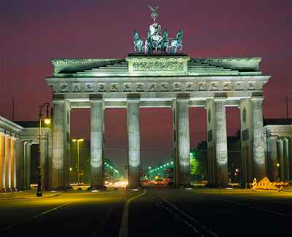 | 6 – 10 June 2013  Berlin  Led by Jackie Parry  Course Cost £530  OU related courses: General Interest/AA318/A226  VIABLE
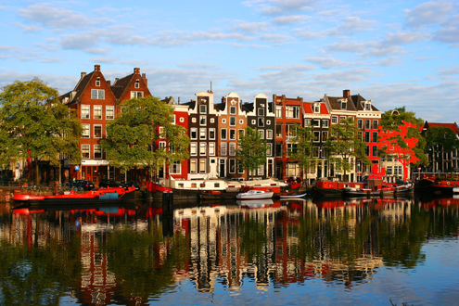 | 23 – 26 June 2013  Amsterdam  Led by Mary Hawkins  Course cost £495  OU related courses: A226/General Interest  VIABLE
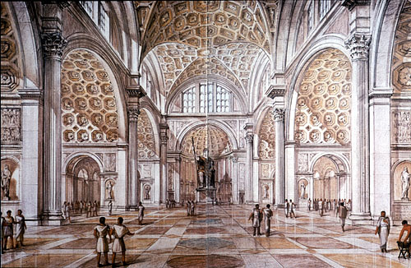 | 6 – 10 September 2013  Christian Rome  Led by Dalila Castelijn  Course Cost £560 (plus flight)  OU related courses: General Interest
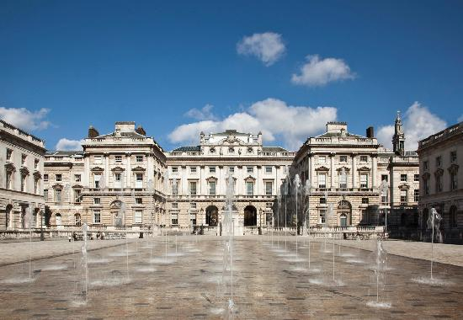 | 18 – 20 October 2013  London, Public and Private Galleries  Led by Jackie Parry  Course Cost £150 (plus hotel if required)  OU related courses: A226/General Interest
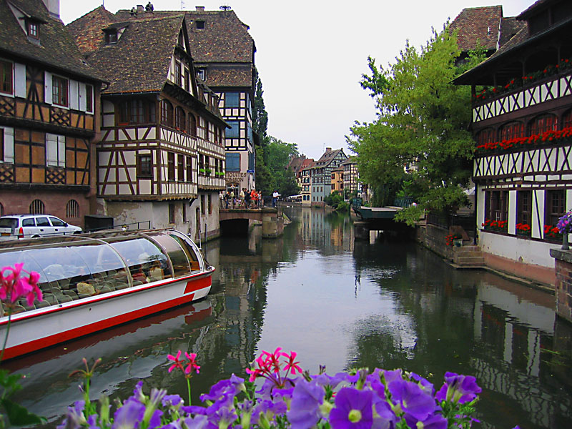 | 7 – 11 November 2013  Strasbourg and Colmar  Led by Mary Hawkins  Course Cost £475 (plus Eurostar and train)  OU related courses: General Interest / Art History Courses
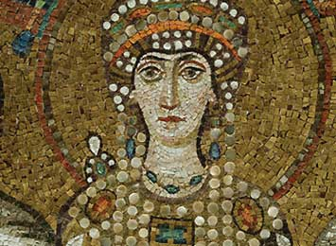 | 15 – 19 November 2013  Ravenna  Led by Daphne Joynes  Course Cost £495 (plus flight)  OU related courses: General Interest/AA315/A226
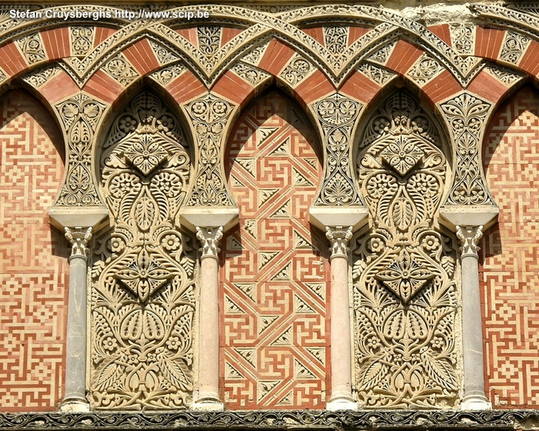 | 24 November - 1 December 2013  Granada, Cordoba & Seville: In the Steps of the Moors  led by Mary Hawkins  Course Cost £755 (plus flight)  OU related courses: General Interest

NEW TOURS FOR 2013

We are offering a number of new tours this year:

CHRISTIAN ROME, led by Dalila Castelijn, 6 – 10 September 2013

This tour is focusing on the art and architecture of Early Christian Rome. Among the catacombs to be visited are St Callisto, St Domitilla and St Priscilla. We will visit the basilicas of San Giovanni in Laterano, Santa Maria Maggiore, Santa Maria in Trastevere; the Mausoleum of Santa Costanza and the St Peter Grottoes at the Vatican. Details are on our website.

LONDON, led by Jackie Parry, 18 – 20 October 2013

For the first time we are proposing a weekend tour tour based around public and private galleries in London. Arrangements are quite flexible, ie those who live in London can attend on a day to day basis without accommodation whereas for those who come from further away we will nominate a central hotel to be booked where the tutor will be residing. This tour is of interest to A226 students but also for those who are generally interested. Get in touch for details.

STRASBOURG AND COLMAR, led by Mary Hawkins, 7 – 11 November 2013
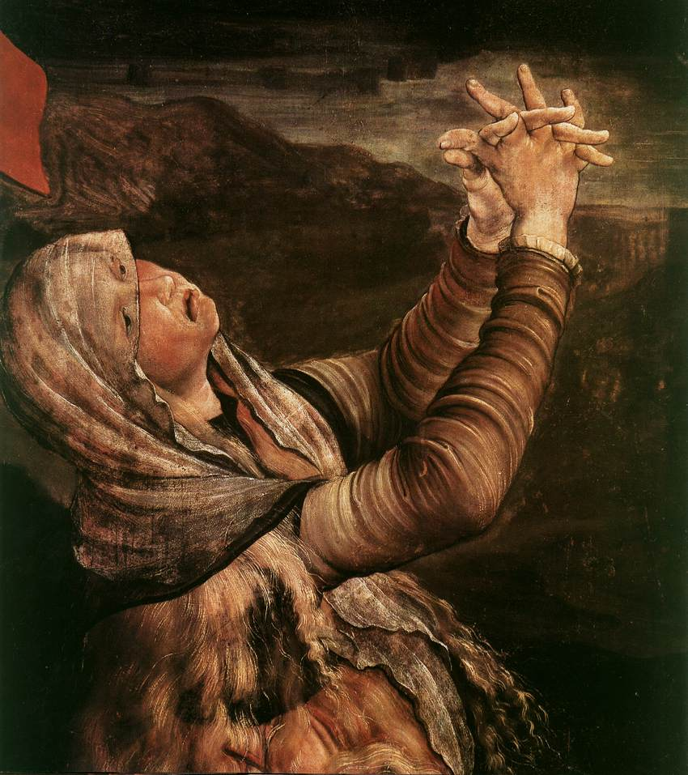

Strasbourg is located in the heart of Alsace and on the borders of France and Germany. It is a stunningly beautiful old town with an awe-inspiring Gothic Cathedral. The tour includes a day visit to Colmar, where you can see Grunewald’s 16th century Issenheim Altarpiece of Christ’s crucifixion (detail on the left). Get in touch for details.

Gallery and Museum Visits

16 Feb 2013 | Renaissance Altarpieces, National Gallery, London | AA315/A226/General Interest | Mary Hawkins | 11:00 – 13:00 | £17.50
16 Feb 2013 | Netherlandish Painting, National Gallery, London | AA315/A226/General Interest | Mary Hawkins | 14:00 – 16:00 | £17.50
23 Feb 2013 | UNDERSTANDING RENAISSANCE ART No 3.  From Rome to the Renaissance – Looking at Sculpture. V&A. | AA315/A226/  General Interest | Daphne Joynes | 14:00 – 16:00 | £17.50
9 March 2013 | The Wallace Collection: An International Treasurehouse (18th Century French Painting) | A226/General Interest | Jackie Parry | 11:00 – 13:00 | £17.50
9 March 2013 | Impressionism, National Gallery London | AA318/A226/General Interest | Jackie Parry | 14:30 – 16:30 | £17.50
16 March 2013 | UNDERSTANDING RENAISSANCE ART No 4.  Aspects of Patronage. NG | AA315/A226/  General Interest | Daphne Joynes | 11:00 – 13:00 | £17.50
16 March 2013 | UNDERSTANDING RENAISSANCE ART No 5.  How Portraiture Developed. NG | AA315/A226/  General Interest | Daphne Joynes | 14:00 – 16:00 | £17.50
27 April 2013 | Victorian Painting,  Tate Britain, London | A226/General Interest | Jackie Parry | 11:00 – 13:00 | £17.50
27 April 2013 | PreRaphaelite Brotherhood,  Tate Britain, London | A226/General Interest | Jackie Parry | 14:00 – 16.00 | £17.50
4 May 2012 | Medieval to Modern: Changes in Techniques and Subjects,  British Museum, London | General Interest /A200 | Dr William Sterling | 11:00 – 13:00 | £17.50
18 May 2013 | Cubism and Abstract Art,  Tate Modern, London | A226/AA318/General Interest | Jackie Parry | 11:00 – 13:00 | £17.50
18 May 2013 | Abstract Expressionism and Conceptual Art,  Tate Modern, London | A226/AA318/General Interest | Jackie Parry | 14:00 – 16:00 | £17.50
25 May 2013 | William Morris Gallery, Lloyd Park in Walthamstow, London | A226/General Interest | Jackie Parry | 11:00 – 13:00 | £17.50
25 May 2013 | William Morris at the Victoria & Albert Museum, London | A226/General Interest | Jackie Parry | 14:30 – 16:30 | £17.50
26 Oct  2013 | Myth in the Greek World,  British Museum, London | A330/General Interest | Dr Sue Blundell | 11:00 – 13:00 | £17.50
26 Oct 2013 | Myth in the Roman World,  British Museum, London | A330/General Interest | Dr Sue Blundell | 14:00 – 16:00 | £17.50
7 Dec 2013 | Sandro Botticelli,  National Gallery, London | A226/General Interest | Mary Hawkins | 11:00 – 13:00 | £17.50
7 Dec 2013 | El Greco: From Crete to Toledo, National Gallery, London | A226/General Interest | Mary Hawkins | 14:00 – 16:00 | £17.50

TUTORS: The tutors for these Gallery and Museum Visits are all experienced Lecturers who have been selected for their skills in communication and teaching. They are able to direct attention to study issues whether at an introductory or advanced level. Siragusa Tours Ltd reserves the right to substitute a named tutor. Tutors/Lecturers will be identified by a badge displaying their name.

GROUP SIZE: For Gallery/Museum Visits the number of participants will usually be no more than 15. This is to ensure the maximum benefit for all participants.

CANCELLATIONS: If Siragusa Tours Ltd is obliged to cancel a particular Gallery/Museum Visit, a full refund will be made. If you are unable to participate and cancel before the event you will receive a voucher to be used at another similar event or you can choose an alternative visit.

MEETING POINTS FOR GALLERY VISITS
National Gallery: ‘Meeting Point’ beside the Information Desk in the Sainsbury Wing
National Portrait Gallery: By the entrance
V&A: Group Entrance in Exhibition Road

Courtauld Institute (Somerset House, The Strand): Under portico outside gallery entrance

Tate Modern: In the Turbine Hall by the Information Desk

Tate Britain: Manton group entrance on Atterbury Street
British Museum: In the Great Court by the Information Desk
Estorick Collection: By the entrance
Wallace Collection: By the entrance
William Morris Gallery (Lloyd Park, Walthamstaw, London): By the Entrance

Siragusa Tours Ltd, Unit 26, JBJ Business Park, Northampton Rd, Blisworth, Northants NN7 3DW
Tel 01604 859491 Fax 01604 858511 info@siragusatours.co.uk www.siragusatours.co.uk

----------------------------------------------------------------------------------------------------------------------------------------------

Gallery and Museum Visits Booking Form

Mr/Mrs/Ms
Address
 |  | Post Code
Phone | Mobile
E-mail
OU Course(s)
Date | Time | Location | Course | Places | Total
 |  |  |  |  | £
 |  |  |  |  | £
 |  |  |  |  | £
 |  |  |  |  | £
 |  |  |  |  | £
 |  |  |  |  | £
 |  |  |  |  | £

I enclose a cheque made payable to Siragusa Tours Ltd for £

