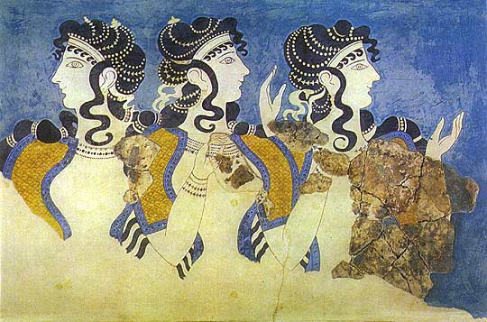
SIRAGUSA TOURS LTD
Art History and Classical Studytours

Newsletter, May 2011
Study Tour Programme

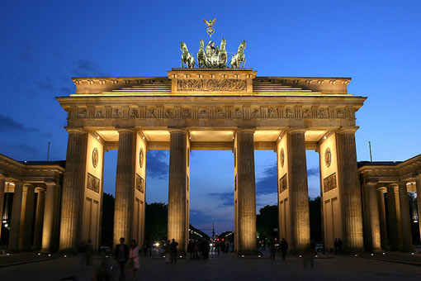 | 2 – 6 June 2011  Berlin  led by Jackie Parry  Course Cost £530 (plus flight)  OU related courses: General Interest  VIABLE MORE PLACES AVAILABLE
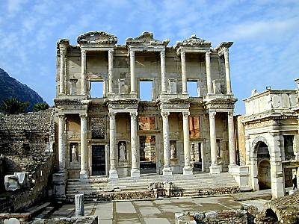 | 8 – 14 September 2011  Classical Western Turkey: Pergamon & Ephesus  led by Dalila Casteljin  Course Cost £645 (plus flight), 4 nights on half-board basis  OU related courses: General Interest/Classics)  VIABLE MORE PLACES AVAILABLE
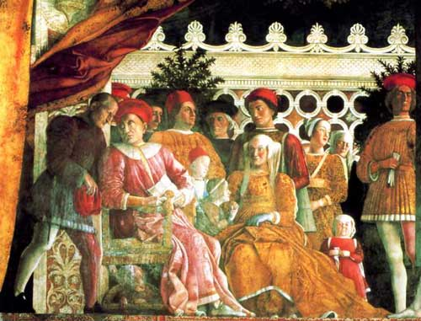 | 27 October – 3rd November 2011  The Renaissance Courts of Mantua, Ferrara & Urbino  led by Daphne Joynes  Course Cost £810 (plus flight)  OU related courses: AA305/AA315/A216/General Interest  VIABLE MORE PLACES AVAILABLE
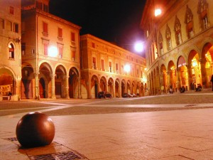 | 4 – 7 November 2011  LRAC Bolgona, led by Mary Hawkins  Course Cost LRAC members £435, non-members £455 (plus flight)  OU related courses: AA305/L195/General Interest  FULLY BOOKED, but contact us to be put on waiting list
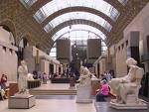 | 18 - 21 November 2011  Paris: Modern Art  led by Jackie Parry  Course Cost £505 (including Eurostar)  OU related courses: AA318/A216/General Interest  VIABLE MORE PLACES AVAILABLE
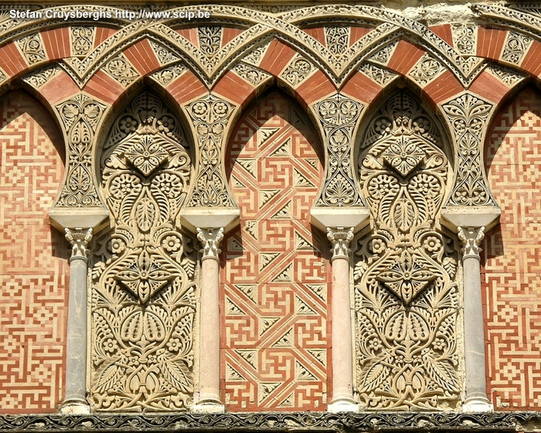 | 20 – 27 November 2011  Granada, Cordoba & Seville: In the Steps of the Moors  led by Mary Hawkins  Course Cost £745 (plus flight)  OU related courses: General Interest  FULLY BOOKED, however, if you are interested please let us know anyway so that we can get in touch if places become available again
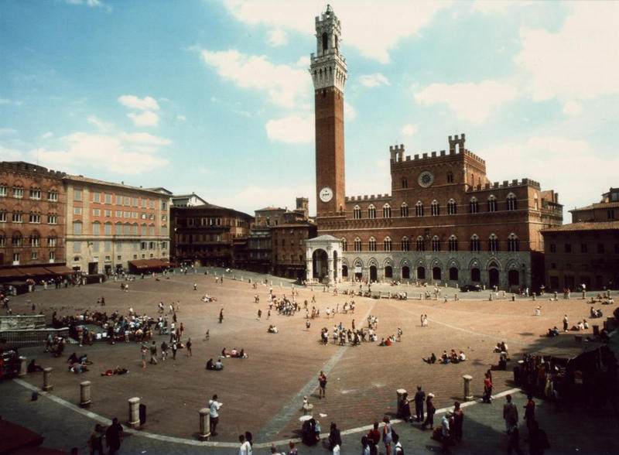 | 1 – 5 March 2012  Siena & San Gimignano: Art and Culture  led by Daphne Joynes  Course Cost £560 (plus flight)  OU related courses: General Interest/AA315/A216
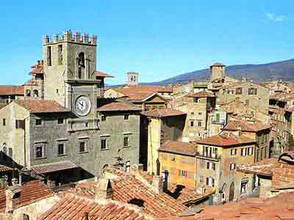 | 6 - 12 March 2012  Cortona, Assisi and Arezzo, half board basis (on 4 of the nights)  Led by Mary Hawkins  Course Cost £870 (plus flight)  OU related courses: General Interest/AA315
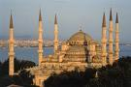 | 19 – 25 April 2012  LRAC Istanbul  Led by Dalila Castelijn  Course Cost LRAC members £725, non-members £745 (plus flight)  OU related courses: General Interest

NEW LRAC TOUR, Istanbul, 19 – 25 April 2012, led by Dalila Casteljin
To secure a place get in touch quickly, details are already available.

ST PETERSBURG, 9 - 14 May 2012, led by Mary Hawkins
As this tour was very popular we are repeating it next year, details will be ready in due course.

TOURS LATER IN THE YEAR
Vienna 24 – 28 May 2012, led by Jackie Parry
Liverpool, 28 June – 1st July 2012, led by Jackie Parry
Trentino & Verona, Sept 2012, led by Dalila Casteljin
Florence, Oct 2012, led by Daphne Joynes
Get in touch to express interest.

MYTH IN THE GREEK AND ROMAN WORLD with Dr Sue Blundell at the British Museum (A330/General Interest), 22 October 2011. You will be looking at a range of Greek myths - involving gods and goddesses, heroes and heroines, and the Trojan War cycle - and their expression and interpretation in visual media. These will include vase paintings, statues, and temple sculptures. You will be concentrating on the diverse forms these myths assume in different parts of the Roman Empire, and their employment in both personal and political contexts.

A PLAY BY DR SUE BLUNDELL: THE HAPPINESS INDEX

What David Cameron can learn from the Greeks and Romans
Performed by David Acton

“Overall, how happy did you feel yesterday?” Faced with this question in a government survey, John turns to a couple of ancient philosophers for advice. So what is happiness anyway? And how do you know when you’ve got it? By the end of the evening you should have a better idea what to say to the P.M. when your survey form pops through the letterbox.

FOR ONE NIGHT ONLY 7.30, Sunday June 19th
At the New End Theatre, 27 New End, Hampstead, London NW3 1JD
Tickets £10 Box Office 0870 033 2733; www.newendtheatre.co.uk, Playing time: 60 minutes

Gallery and Museum Visits

22 Oct  2011 | Myth in the Greek World,  British Museum, London | A330/General Interest | Dr Sue Blundell | 11:00 – 13:00 | £17.50
22 Oct 2011 | Myth in the Roman World,  British Museum, London | A330/General Interest | Dr Sue Blundell | 14:00 – 16:00 | £17.50
28 Jan 2012 | Making Renaissance Art: Craftsmanship and Technique in early Italian Painting, NG | AA315/A216/  A840/General Interest | Daphne Joynes | 11:00 – 13:00 | £17.50
11 Feb 2012 | From Early to High Renaissance: Continuity and Change in Italian Painting, National Gallery | AA315/A216/  A840/General Interest | Daphne Joynes | 11:00 – 13:00 | £17.50
18 Feb 2012 | Renaissance Altarpieces, National Gallery, London | AA315/General Interest | Mary Hawkins | 11:00 – 13:00 | £17.50
18 Feb 2012 | Netherlandish Painting, National Gallery, London | AA315/General Interest | Mary Hawkins | 14:00 – 16:00 | £17.50
10 March 2012 | The Wallace Collection: An International Treasurehouse (18th Century French Painting) | A216/General Interest | Jackie Parry | 11:00 – 13:00 | £17.50
10 March 2012 | Impressionism, National Gallery London | AA318/General Interest | Jackie Parry | 14:30 – 16:30 | £17.50
24 March 2012 | Different Views of Art: Patronage in Italy Outside Florence  National Gallery, London | AA315/A216/  A840/General Interest | Daphne Joynes | 11:00 – 13:00 | £17.50
21 April 2012 | Topics for Projects and Independent Essays,  National Gallery, London | AA315 | Daphne Joynes | 11:00 – 13:00 | £17.50
28 April 2012 | Victorian Painting, Tate Britain, London | A216/General Interest | Jackie Parry | 11:00 – 13:00 | £17.50
28 April 2012 | PreRaphaelite Brotherhood, Tate Britain, London | A216/General Interest | Jackie Parry | 14:00 – 16.00 | £17.50
12 May 2012 | Cubism to Abstraction, Tate Modern, London | A216/AA318/General Interest | Jackie Parry | 11:00 – 13:00 | £17.50
12 May 2012 | New, Newer, Newest: Conceptualism and After, Tate Modern, London | A216/AA318/General Interest | Jackie Parry | 14:00 – 16:00 | £17.50

TUTORS: The tutors for these Gallery and Museum Visits are all experienced Lecturers who have been selected for their skills in communication and teaching. They are able to direct attention to study issues whether at an introductory or advanced level. Siragusa Tours Ltd reserves the right to substitute a named tutor. Tutors/Lecturers will be identified by a badge displaying their name.

GROUP SIZE: For Gallery/Museum Visits the number of participants will usually be no more than 15. This is to ensure the maximum benefit for all participants.

CANCELLATIONS: If Siragusa Tours Ltd is obliged to cancel a particular Gallery/Museum Visit, a full refund will be made. If you are unable to participate and cancel before the event you will receive a voucher to be used at another similar event or you can choose an alternative visit.

MEETING POINTS FOR GALLERY VISITS
National Gallery: ‘Meeting Point’ beside the Information Desk in the Sainsbury Wing
National Portrait Gallery: By the entrance
V&A: Group Entrance in Exhibition Road
Courtauld Institute (Somerset House, The Strand): Under portico outside gallery entrance
Tate Modern: In the Turbine Hall by the Information Desk
Tate Britain: Manton group entrance on Atterbury Street
British Museum: In the Great Court by the Information Desk
Estorick Collection: By the entrance

Siragusa Tours Ltd, Unit 26, JBJ Business Park, Northampton Rd, Blisworth, Northants NN7 3DW
Tel 01604 859491 Fax 01604 858511 info@siragusatours.co.uk www.siragusatours.co.uk

----------------------------------------------------------------------------------------------------------------------------------------------
Gallery and Museum Visits Booking Form

Mr/Mrs/Ms
Address
 |  | Post Code
Phone | Mobile
E-mail
OU Course(s)
Date | Time | Location | Course | Places | Total
 |  |  |  |  | £
 |  |  |  |  | £
 |  |  |  |  | £
 |  |  |  |  | £
 |  |  |  |  | £
 |  |  |  |  | £
 |  |  |  |  | £

I enclose a cheque made payable to Siragusa Tours Ltd for £

