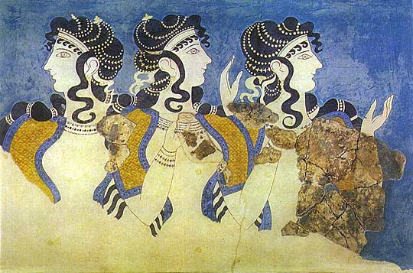
SIRAGUSA TOURS LTD

Art History and Classical Studytours

Newsletter, May 2012

Study Tour Programme

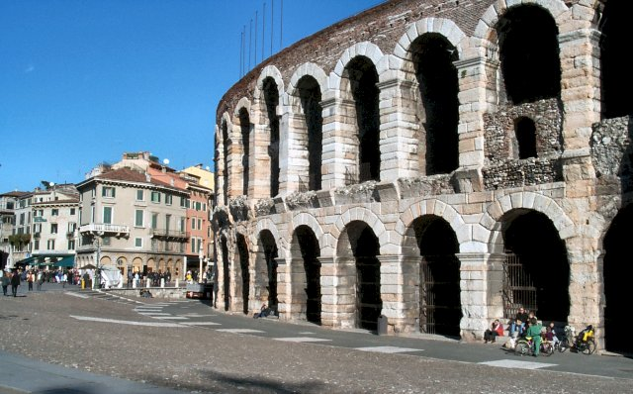 | 6 – 11 September 2012  Trento and Verona  Led by Dalila Castelijn  Course cost £645 (plus flight)  OU related courses: General Interest/AA315/Classics
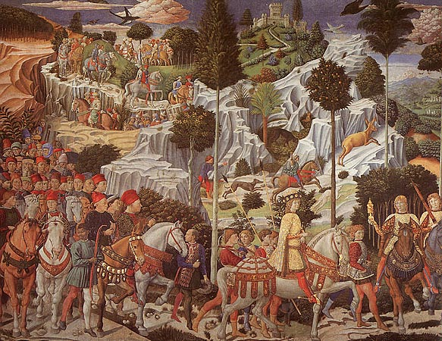 | 29 October – 3 November 2012  Renaissance Florence and Fiesole  Led by Daphne Joynes  Course Cost £545 (plus flight)  OU related courses: AA315/A226/General Interest
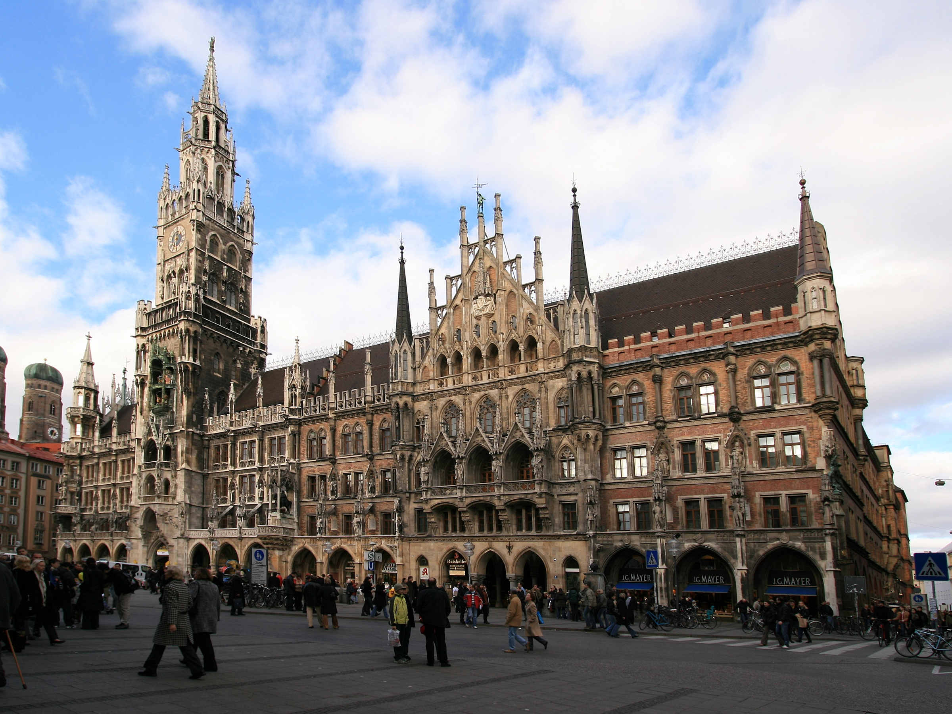 | 2 - 5 November 2012  LRAC MUNICH  Led by Mary Hawkins  Course Cost £445 (plus flight)  OU related courses: General Interest
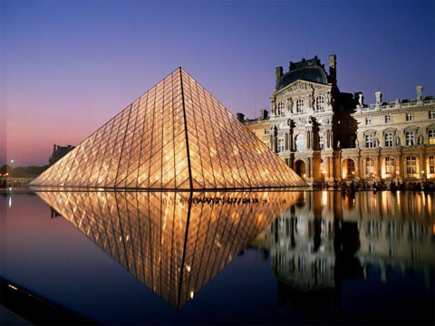 | 16 - 19 November 2012  Paris: Modern Art  Led by Jackie Parry  Course Cost £545 (including Eurostar)  OU related courses: AA318/A226/General Interest
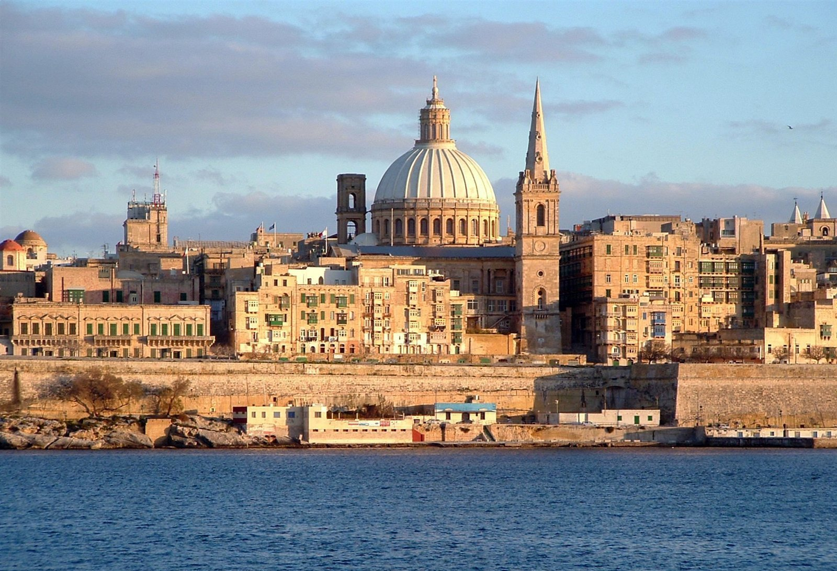 | 21 – 26 November 2012  Malta  Led by Mary Hawkins  Course Cost £685 (plus flight)  OU related courses: General Interest/A226/AA315  2 PLACES LEFT
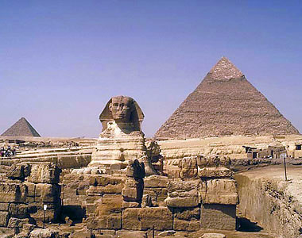 | 25 – 31 January 2013  Cairo and Luxor  Led by Dalila Castelijn  Course Cost £795 (plus flight)  OU related courses: General Interest
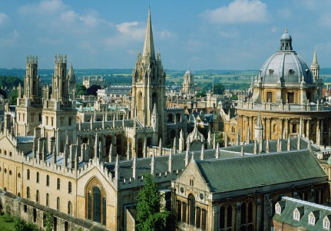 | 15 – 17 March 2013  Oxford  led by Jackie Parry  Course Cost £290  OU related courses: General Interest
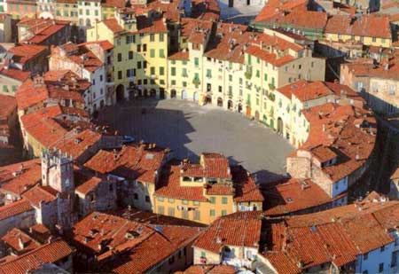 | 10 – 15 April 2013  Lucca, Puccini and the Merchant of Prato  Led by Mary Hawkins  Course Cost £590 (plus flight)  OU related courses: AA315/A226/General Interest
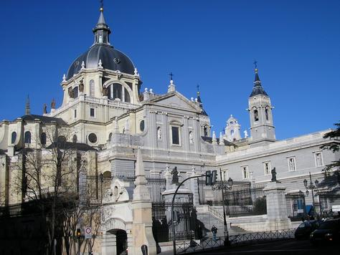 | 9 – 14 May 2013  Madrid, Toledo, El Escorial  Led by Jackie Parry  Course Cost £620 (plus flight)  OU related courses: General Interest

CUBISM TO ABSTRACTION & New, Newer, Newest: Conceptualism and After
These Gallery Visits at the Tate Modern, which were cancelled on 12 May have been rescheduled to 23 June 2012. There are places available.

LRAC TOUR
MUNICH, 2 – 5 November 2012, led by Mary Hawkins; please get in touch there are still places available.

NEW EXCITING DESTINATION
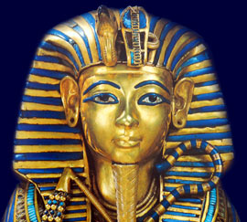
We have a new exciting destination on our programme to Egypt to visit CAIRO AND LUXOR, led by Dalila Castelijn, 25th – 31st January 2013. Full details are on our website or contact us to request them. We need 13 people to make this tour viable, so please get in touch if you are interested.

TOURS LATER IN THE YEAR 2013

Berlin, 6 – 10 June 2013, led by Jackie Parry

Amsterdam, 21 – 24 June 2013, led by Mary Hawkins

Ravenna, 15 – 19 November, led by Daphne Joynes

GALLERY VISITS FOR NEW OU COURSE, A226

Look out for numerous new Gallery Visits in the programme below in relation to the new OU Course A226, looking at Botticelli, El Greco, the PreRaphaelite Brotherhood, William Morris, Cubism and Abstract Art, Abstract Expressionism and Conceptual Art in various London Galleries, led by Mary Hawkins and Jackie Parry.

Gallery and Museum Visits

26 May 2012 | Fascinating Faces: A Study of Portraits, National Gallery, London | General Interest/A216 | Mary Hawkins | 11:00 – 13:00 | £17.50
23 June 2012 | Cubism to Abstraction, Tate Modern, London | A216/AA318/General Interest | Jackie Parry | 11:00 – 13:00 | £17.50
23 June 2012 | New, Newer, Newest: Conceptualism and After, Tate Modern, London | A216/AA318/General Interest | Jackie Parry | 14:00 – 16:00 | £17.50
27 Oct  2012 | Myth in the Greek World,  British Museum, London | A330/General Interest | Dr Sue Blundell | 11:00 – 13:00 | £17.50
27 Oct 2012 | Myth in the Roman World,  British Museum, London | A330/General Interest | Dr Sue Blundell | 14:00 – 16:00 | £17.50
8 Dec 2012 | Sandro Botticelli, National Gallery, London | A226/General Interest | Mary Hawkins | 11:00 – 13:00 | £17.50
8 Dec 2012 | El Grecoi: From Crete to Toledo, National Gallery, London | A226/General Interest | Mary Hawkins | 14:00 – 16:00 | £17.50
26 Jan 2013 | UNDERSTANDING RENAISSANCE ART No 1.  1300 – 1400 Making and Meaning. National Gallery, London | AA315/A226/  General Interest | Daphne Joynes | 11:00 – 13:00 | £17.50
26 Jan 2013 | UNDERSTANDING RENAISSANCE ART No 2.  1400 – 1600 Continuity and Change. National Gallery, London | AA315/A226/  General Interest | Daphne Joynes | 14:00 – 16:00 | £17.50
16 Feb 2013 | Renaissance Altarpieces, National Gallery, London | AA315/A226/General Interest | Mary Hawkins | 11:00 – 13:00 | £17.50
16 Feb 2013 | Netherlandish Painting, National Gallery, London | AA315/A226/General Interest | Mary Hawkins | 14:00 – 16:00 | £17.50
23 Feb 2013 | UNDERSTANDING RENAISSANCE ART No 3.  From Rome to the Renaissance – Looking at Sculpture. V&A. | AA315/A226/  General Interest | Daphne Joynes | 14:00 – 16:00 | £17.50
9 March 2013 | The Wallace Collection: An International Treasurehouse (18th Century French Painting) | A226/General Interest | Jackie Parry | 11:00 – 13:00 | £17.50
9 March 2013 | Impressionism, National Gallery London | AA318/A226/General Interest | Jackie Parry | 14:30 – 16:30 | £17.50
16 March 2013 | UNDERSTANDING RENAISSANCE ART No 4.  Aspects of Patronage. NG | AA315/A226/  General Interest | Daphne Joynes | 11:00 – 13:00 | £17.50
16 March 2013 | UNDERSTANDING RENAISSANCE ART No 5.  How Portraiture Developed. NG | AA315/A226/  General Interest | Daphne Joynes | 14:00 – 16:00 | £17.50
27 April 2013 | Victorian Painting, Tate Britain, London | A226/General Interest | Jackie Parry | 11:00 – 13:00 | £17.50
27 April 2013 | PreRaphaelite Brotherhood, Tate Britain, London | A226/General Interest | Jackie Parry | 14:00 – 16.00 | £17.50
4 May 2012 | Medieval to Modern: Changes in Techniques and Subjects | General Interest /A200 | Dr William Sterling | 11:00 – 13:00 | £17.50
18 May 2013 | Cubism and Abstract Art, Tate Modern, London | A226/AA318/General Interest | Jackie Parry | 11:00 – 13:00 | £17.50
18 May 2013 | Abstract Expressionism and Conceptual Art, Tate Modern, London | A226/AA318/General Interest | Jackie Parry | 14:00 – 16:00 | £17.50
25 May 2013 | William Morris Gallery, Lloyd Park in Walthamstow, London | A226/General Interest | Jackie Parry | 11:00 – 13:00 | £17.50
25 May 2013 | William Morris at the Victoria & Albert Museum, London | A226/General Interest | Jackie Parry | 14:30 – 16:30 | £17.50

TUTORS: The tutors for these Gallery and Museum Visits are all experienced Lecturers who have been selected for their skills in communication and teaching. They are able to direct attention to study issues whether at an introductory or advanced level. Siragusa Tours Ltd reserves the right to substitute a named tutor. Tutors/Lecturers will be identified by a badge displaying their name.

GROUP SIZE: For Gallery/Museum Visits the number of participants will usually be no more than 15. This is to ensure the maximum benefit for all participants.

CANCELLATIONS: If Siragusa Tours Ltd is obliged to cancel a particular Gallery/Museum Visit, a full refund will be made. If you are unable to participate and cancel before the event you will receive a voucher to be used at another similar event or you can choose an alternative visit.

MEETING POINTS FOR GALLERY VISITS
National Gallery: ‘Meeting Point’ beside the Information Desk in the Sainsbury Wing
National Portrait Gallery: By the entrance
V&A: Group Entrance in Exhibition Road

Courtauld Institute (Somerset House, The Strand): Under portico outside gallery entrance

Tate Modern: In the Turbine Hall by the Information Desk

Tate Britain: Manton group entrance on Atterbury Street
British Museum: In the Great Court by the Information Desk
Estorick Collection: By the entrance
Wallace Collection: By the entrance
William Morris Gallery (Lloyd Park, Walthamstaw, London): By the Entrance

Siragusa Tours Ltd, Unit 26, JBJ Business Park, Northampton Rd, Blisworth, Northants NN7 3DW
Tel 01604 859491 Fax 01604 858511 info@siragusatours.co.uk www.siragusatours.co.uk

----------------------------------------------------------------------------------------------------------------------------------------------

Gallery and Museum Visits Booking Form

Mr/Mrs/Ms
Address
 |  | Post Code
Phone | Mobile
E-mail
OU Course(s)
Date | Time | Location | Course | Places | Total
 |  |  |  |  | £
 |  |  |  |  | £
 |  |  |  |  | £
 |  |  |  |  | £
 |  |  |  |  | £
 |  |  |  |  | £
 |  |  |  |  | £

I enclose a cheque made payable to Siragusa Tours Ltd for £

