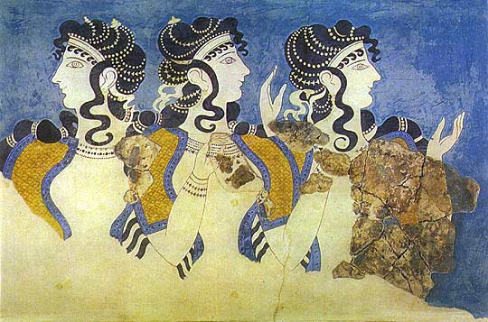
SIRAGUSA TOURS LTD
Art History and Classical Studytours

Newsletter, Spring 2010
Study Tour Programme

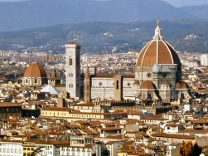 | 16 – 22 April 2010  Renaissance Florence and Siena  led by Mary Hawkins  Course Cost £695 (plus flight) OU related courses: AA315/A216/General Interest  VIABLE MORE PLACES AVAILABLE
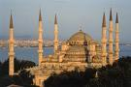 | 21 – 27 April 2010  Istanbul  led by Dalila Castelijn  Course Cost £695 (plus flight) OU related courses: General Interest  FULLY BOOKED
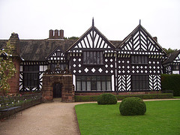 | 8 - 11 May 2010  Liverpool  led by Jackie Parry and limited to 10 people  Course Cost £300 (plus train) OU related courses: General Interest/A216/AA315
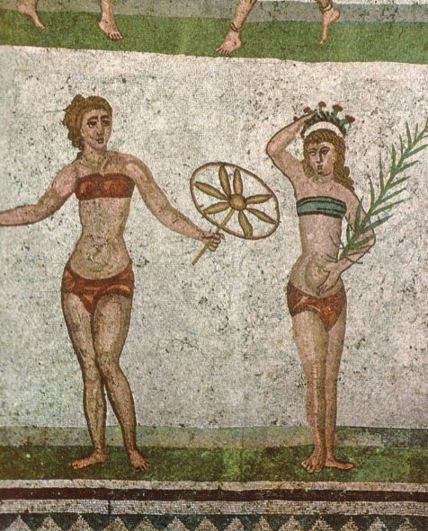 | 19 - 25 May 2010  Sicily: Heritage, History and Art, led by Dr Neil Faulkner  Course Cost £825 (plus flight)  OU related courses: General Interest/Classics/A219  2 MORE PLACES AVAILABLE
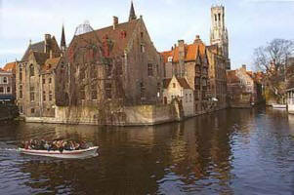 | 2 – 7 June 2010  Bruges, Antwerp and Ghent led by Mary Hawkins  Course Cost £665 (includes Eurostar)  OU related courses: A216/AA315/General Interest  VIABLE MORE PLACES AVAILABLE
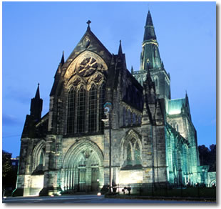 | 17 – 21 June 2010  Glasgow, led by Mary Hawkins  Course Cost £415 (plus train or flight)  OU related courses: General Interest  VIABLE MORE PLACES AVAILABLE
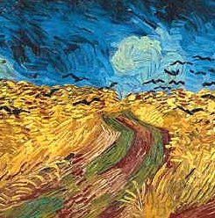 | 27 – 30 August 2010  Amsterdam and Delft  led by Jackie Parry  Course Cost £490 (plus flight)  OU related courses: General Interest/A216
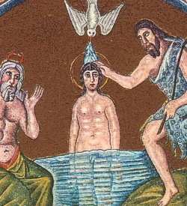 | 18 – 23 October 2010  Ravenna, Rimini & Urbino  led by Daphne Joynes  Course Cost £665 (plus flight)  OU related courses: General Interest/AA315/A216
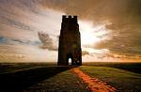 | 26 - 30 October 2010  Glastonbury, Soul’s Journey Course / Tour  led by Chrissy Holmes  Course Cost £515 (plus travel)  For those interested in ‘spiritual growth’
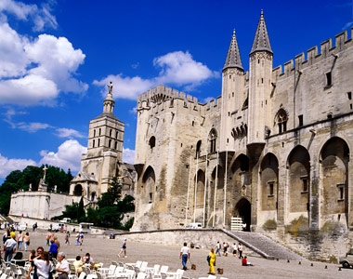 | 4 – 8 November 2010  LRAC Avignon  led by Mary Hawkins  Course Cost LRAC members £695, non-members £715 (including Eurostar and TGV train)  OU related courses: General Interest/Classical Courses/AA315
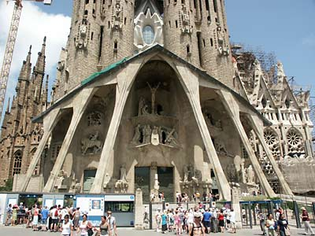 | 10 - 15 November 2010  Barcelona, led by Mary Hawkins  Course Cost £685 (plus flight)  OU related courses: General Interest  3 PLACES LEFT
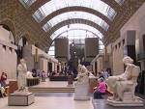 | 19 - 22 November 2010  Paris: Modern Art  led by Jackie Parry  Course Cost £505 (including Eurostar)  OU related courses: AA318/A216/General Interest
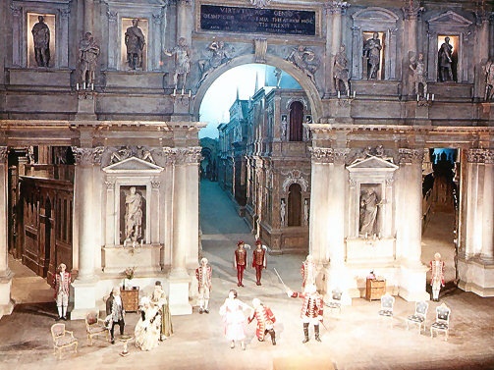 | 30 November – 6 December 2010  Stunning Vicenza, Beautiful Padua and Glorious Venice  led by Daphne Joynes  Course Cost £695 (plus flight)  OU related courses: AA315/A216/General Interest
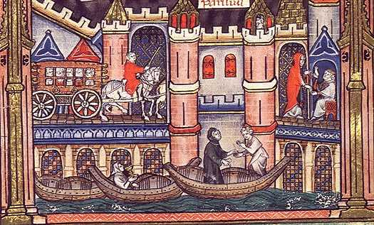 | 29 March – 2 April 2011  Medieval Paris  led by Mary Hawkins  Course Cost £640 (including Eurostar)  OU related courses: AA315/General Interest
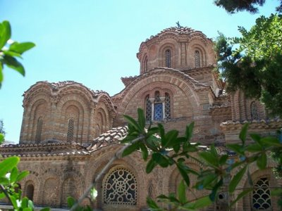 | 7 – 11 April 2011  Byzantine Thessalonike  led by Dr Lyn Rodley  Course Cost £460 (plus flight)  OU related courses: General Interest
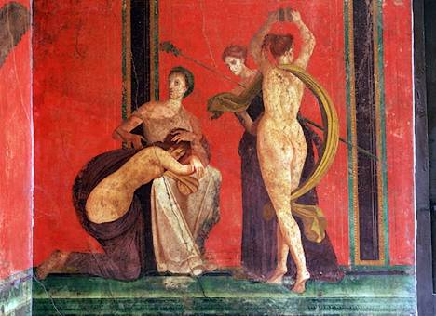 | 4 – 10 May 2011  LRAC Rome, Pompei & Herculaneum, Myth in the Roman World  led by Dr Neil Faulkner  Course Cost LRAC members £845, non-members £865 (plus flight), 3 nights on half-board basis  OU related courses: A330/General Interest

LRAC TOURS
The LRAC post exam tour is Avignon, 4 – 8 Nov 2010, led by Mary Hawkins, and for May 2010 we have organised Rome, Pompei & Herculaneum: Myth in the Roman World led by Dr Neil Faulkner, this is of interest for people doing the new OU Classics course A330. Please contact us for info or have a look on our website.

NEW STUDY TOURS FOR 2011
St Petersburg, 17 – 23 May 2011 (General Interest) led by Mary Hawkins; Mantua, Ferrara & Urbino, October 2011 (AA315/A216/A840), led by Daphne Joynes. To express interest or make other proposals please get in touch. Remember we can also organise tailor made tours on behalf of tutors or small groups.

NEW GALLERY / MUSEUM VISITS
In view of the reopening of the new sculpture galleries at the V&A we have added a visit on 29th May 2010 to look at Renaissance Sculpture, with Daphne Joynes. For the new Classics course A330, Myth in the Greek and Roman Worlds (starting Oct 2010) we have two British Museum Visits on 30th October 2010, guided by Dr Sue Blundell. Another new visit to the V&A, titled Medieval Art & Architecture is with Mary Hawkins on 4th December 2010. NOTE: the CARAVAGGIO visit takes place on 22nd May 2010 (and not on 21st as previously announced).

SIRAGUSA TOURS
Just reminding you again of the recent changes we made: cheques must be made out to ‘SIRAGUSA TOURS LTD’; for electronic transfers the sort code is 20 40 71, account no 33578941, from abroad IBAN GB68 BARC 2040 71335789 41 SWIFTBIC BARCGB22; our new e-mail is info@siragusatours.co.uk; the new website www.siragusatours.co.uk

COURSE ASSISTANT wanted urgently for Bruges, Antwerp & Ghent, 2 – 7 June 2010.

Gallery and Museum Visits

20 March 2010 | Viewing Renaissance Art: Continuity and Change in 15th Century Painting, National Gallery | AA315/A216  General Interest | Daphne Joynes | 11:00 – 13:00 | £17.50
24 April 2010 | Victorian Painting, Tate Britain, London | A216/General Interest | Jackie Parry | 11:00 – 13:00 | £17.50
24 April 2010 | PreRaphaelite Brotherhood, Tate Britain, London | A216/General Interest | Jackie Parry | 14:00 – 16.00 | £17.50
8 May  2010 | The Male and Female Nude 1470 – 1900, National Gallery, London | A216/General Interest | Jacqui Ansell | 11:00 - 13:00 | £17.50
15 May 2010 | Surrealism in Europe, Tate Modern, London | A216/AA318/General Interest | Jackie Parry | 11:00 – 13:00 | £17.50
22 May  2010 | Caravaggio, National Gallery, London | A840/General Interest | Mary Hawkins | 11:00 - 13:00 | £17.50
29 May  2010 | DAY VISIT TO BRIGHTON  Royal Pavillion and Gardens  Brighton Museum and Art Gallery (further info available on request) | General Interest  A216 | Jackie Parry | 10:00 - 16:30 | £40
29 May  2010 | Looking at Sculpture:  The New V&A Renaissance Sculpture Galleries | AA315/A216/  General Interest | Daphne Joynes | 11:00 - 13:00 | £17.50
5 June  2010 | Art and Death in 15th Century Italy, National Gallery, London | AA315/General Interest | Daphne Joynes | 11:00 – 13:00 | £17.50
30 Oct  2010 | Myth in the Greek World,  British Museum, London | A330/General Interest | Dr Sue Blundell | 11:00 – 13:00 | £17.50
30 Oct 2010 | Myth in the Roman World,  British Museum, London | A330/General Interest | Dr Sue Blundell | 14:00 – 16:00 | £17.50
27 Nov 2010 | Impressionism, Post-Impressionism and Fauvism, Courtauld Institute, London | A216/AA318 General Interest | Ron Matthews | 14:00 - 16:00 | £17.50
4 Dec 2010 | Medieval Art & Architecture,  V&A, London | AA315/General Interest | Mary Hawkins | 11:00 – 13:00 | £17.50
29 Jan 2011 | Viewing Renaissance Art: Continuity and Change in 15th Century Painting, National Gallery | AA315/A216/  A840/General Interest | Daphne Joynes | 11:00 – 13:00 | £17.50
5 Feb  2011 | The Shock of the New, the explosion of Modern Art 1900-1914, Tate Modern, London | AA318/A216/General Interest | Ron Matthews | 14:00 – 16:00 | £17.50
19 Feb 2011 | Renaissance Altarpieces,  National Gallery, London | AA315/ General Interest | Mary Hawkins | 11:00 - 13:00 | £17.50
19 Feb 2011 | Netherlandish Painting,  National Gallery, London | AA315/ General Interest | Mary Hawkins | 14:00 - 16:00 | £17.50
28 Feb 2011 | From Early to High Renaissance: How Painting Developed in Florence, Venice and Rome, National Gallery, London | AA315/A216/  A840/General Interest | Daphne Joynes | 11:00 – 13:00 | £17.50
5 March 2011 | Futurism and Modernism,  Estorick Collection, Highbury & Islington Tube, London | AA318/A216/General Interest | Ron Matthews | 14:00 – 16:00 | £17.50 plus entry
26 March 2011 | Different Views of Art: Patronage in Italy Outside Florence  National Gallery, London | AA315/A216/  A840/General Interest | Daphne Joynes | 11:00 – 13:00 | £17.50

TUTORS: The tutors for these Gallery and Museum Visits are all experienced Lecturers who have been selected for their skills in communication and teaching. They are able to direct attention to study issues whether at an introductory or advanced level. Siragusa Tours Ltd reserves the right to substitute a named tutor. Tutors/Lecturers will be identified by a badge displaying their name.

GROUP SIZE: For Gallery/Museum Visits the number of participants will usually be no more than 15. This is to ensure the maximum benefit for all participants.

CANCELLATIONS: If Siragusa Tours Ltd is obliged to cancel a particular Gallery/Museum Visit, a full refund will be made. If you are unable to participate and cancel before the event you will receive a voucher to be used at another similar event or you can choose an alternative visit.

MEETING POINTS FOR GALLERY VISITS
National Gallery: ‘Meeting Point’ beside the Information Desk in the Sainsbury Wing
National Portrait Gallery: By the entrance
V&A: Group Entrance in Exhibition Road
Courtauld Institute (Somerset House, The Strand): Under portico outside gallery entrance
Tate Modern: In the Turbine Hall by the Information Desk
Tate Britain: Manton group entrance on Atterbury Street
British Museum: In the Great Court by the Information Desk
Estorick Collection: By the entrance

Siragusa Tours Ltd, Unit 26, JBJ Business Park, Northampton Rd, Blisworth, Northants NN7 3DW
Tel 01604 859491 Fax 01604 858511 info@siragusatours.co.uk www.siragusatours.co.uk
----------------------------------------------------------------------------------------------------------------------------------------------
Gallery and Museum Visits Booking Form

Mr/Mrs/Ms
Address
 |  | Post Code
Phone | Mobile
E-mail
OU Course(s)
Date | Time | Location | Course | Places | Total
 |  |  |  |  | £
 |  |  |  |  | £
 |  |  |  |  | £
 |  |  |  |  | £

I enclose a cheque made payable to Siragusa Tours Ltd for £

