Amsterdam and Delft
27 - 30 Aug 2010

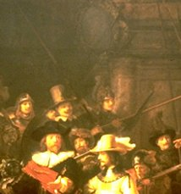  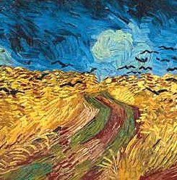 | The 17th century is the period of greatest achievement in Dutch art: it is the age of Rembrandt, Frans Hals, Steen, Vermeer, and Pieter de Hooch. It is also the period in which these Dutch artists invented three new categories of painting: the landscape painting, the still life painting, and the genre painting. This was also the period of the craze for tulips, originally imported from Turkey, ‘tulipmania’ grew so quickly, with tulip bulbs being bought and sold for vast sums of money that it nearly brought the Dutch economy down in a fit of speculative buying and selling. In the 19th and 20th century it was artists such as Van Gogh, Mondrian, and de Kooning that defined the Dutch contribution to modern culture. Today it is the mix of this tradition and the contemporary that mark Amsterdam as a modern European capital.  Amsterdam, perhaps unjustly infamous for its ‘red light’ district, its cannabis cafes and the tradition of ‘youth culture’, is more properly famous for its heritage and culture that harks back to its foundation in Roman antiquity when it was centre of the Batavian republic, its flowering in the period of the Renaissance and especially the period beginning in the late 16th century when the ‘golden age’ of the Dutch Republic began. The United Provinces of the Netherlands, as they chose to call themselves after gaining their independence from Spain after the Eighty Years War, rapidly became in the 17th century a paradigmatic ‘modern’ state in which a quasi-democratic system of government operated in each Province dominated by city burghers (the forerunners of the bourgeois class). Dominated by a staunch Protestantism that favoured mercantile activity (as well as clean living) combined with a scientific approach to nature meant that the Dutch prospered to the extent that, as the historian Simon Schama put it: there was an embarrassment of riches.

Accommodation | Hotel *** Single room supplement £110
Hotel Avenue*** in Amsterdam within reach of the main cultural sites. Accommodation in twin-bedded rooms with private facilities.
Course Cost | £490
Inclusive of tuition, airport transfers (airport transfers are only available for the Siragusa Ltd nominated flight), travel to Delft, accommodation and breakfast.
Travel Insurance
Once tour is viable and if we have booked a flight for you through Travelpack, you can call Larraine on 08444 930465 for an immediate quote (unless you already have insurance)
Flight | Ca £170 scheduled flight to Amsterdam
Note that the cost is an estimate and if it is less you pay less. Please see Booking Conditions for more information concerning nominated flights
Local Transport
Airport transfers by train, travel to Delft by train
Group Size | 16
Tutor | Jackie Parry
Jackie Parry MA, is an experienced lecturer and art historian who has led many gallery visits and study tours. She teaches art history at the University of Sussex and the Open University. She has also lectured for NADFAS, the U3A and the National Trust. Her interests are mostly based around 18th century art and culture and the development of modernism from 19th century to the present. Her MA research included issues of gender and critical theory.
Related OU Courses | General Interest/A216

Itinerary
DAY 01
Arrival at Amsterdam airport, transfer to Hotel. Orientation and Rembrandt House
DAY 02
Van Gogh Museum, Rijksmuseum
DAY 03
Day Visit to Delft
DAY 04
Stedelijk Museum. Departure.
This itinerary and study programme is provisional and may be subject to change in response to local conditions

Siragusa Ltd, Unit 26, JBJ Business Park,
Northampton Rd, Blisworth, Northants, NN7 3DW
Tel: 01604 859491 Fax : 01604 858511
info@siragusatours.co.uk www.siragusatours.co.uk

