Soul’s Journey Tour
Glastonbury, 26 - 30 October 2010

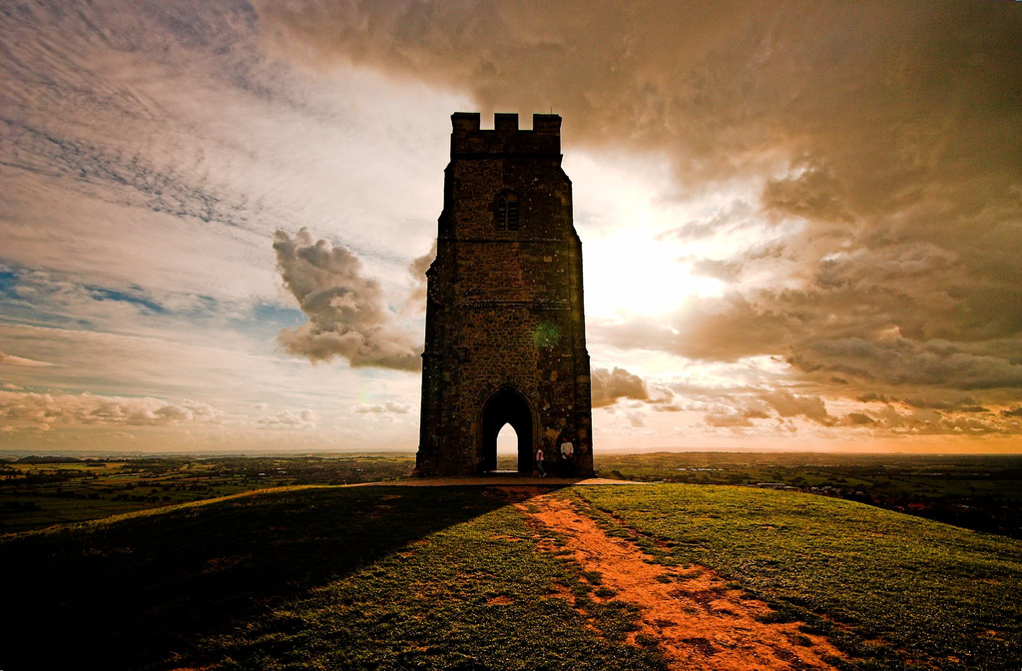  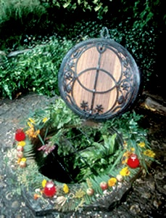 | THROUGH TIME  A guided tour through the magical Glastonbury landscape. We begin with a short walk along one of the many ley-lines that converge on Glastonbury, then walk on to the rounded, feminine Chalice Hill (so called because the Chalice of Christ’s blood is buried there) then we are summoned to the Tor by its imperious masculine energy to see the pilgrimage tracks around it and climb onto its heights. Here we see fantastic views of the Levels, Wearyall Hill, with its Holy Thorn and the town of Glastonbury buried in its sacred surroundings. A map will be shown of the ancient landscape before the levels were drained showing the Isle of Avalon as it was. We then complete the tour by walking down to the outlet of the two Holy Springs – Red and White which some associate with Merlin and the Red and White Dragons.  ANCIENT CONNECTIONS  We shall walk along Chilkwell Street (a corruption of the name Chalice Well), to enter the world famous Peace Gardens which nestle on the lower slopes of Chalice hill. It is near the Well head itself that the Chalice was buried that Joseph of Arimethea broughtto England on his trade journeys here. It is said to contain the drops of blood from the crucified Christ. From this it is only a short step to the Grail Legend and King Arthur. There is an intimate visual connection from here with the Tor and many meditation areas in the gardens to connect you with the nature spirits, or Higher Beings. The feminine energy is very close here.

THE SOUL’S JOURNEY COURSE
An important aspect of this tour are the 9 workshops (for titles see itinerary below), each 1.5 hours long, led by Chrissy Holmes.
General description What is meant by spirituality? How is it different from religion? How does it affect you? This course seeks to answer these questions through understanding both your own personal experience and the teachings of traditional faiths – western, eastern and tribal.
What previous knowledge/experience is required? This course is open to everyone interested in the spiritual aspect of life – whatever your religious or non-religious background.
Course Content This course is based both on insights from your own & your fellow students’ personal experience & from the teachings of all faiths.
Materials you will need Paper & pen.
What you should be able to do by the end of the course Have a greater understanding of contemporary spirituality & your own spirituality; have more clarity about your next steps in exploring spirituality.
The teaching & learning methods used on the course
These will include talks & discussions, individual & group exercises.
How your progress is assessed
Through discussion, observation & practical activities.
What extra study/practice is expected outside the class Nothing is required of you. There is, however, a reading list & you might also want to keep a journal; & there are suggestions for optional homework.
What you can do next, after this course Other personal development and spiritual courses. One of the elements of this course is to explore next steps.
Accommodation | Single room supplement £160
B&B breakfast accommodation within reach of main attractions
Cost | £515
Inclusive of local visits, workshops, accommodation on a bed and breakfast basis.
Note that the cost per meditation session is £10 to be shared between those wishing to participate. Chrissy is also offering healing, Core Energy Management and Spiritual Companionship sessions on an individual basis, Wednesday, Thursday and Friday evenings for £20 a time.
Travel Insurance
Please make own arrangements if you require insurance
Travel | (not included in course cost)
From London: Trains run from London Paddington to Bristol Temple Meads.
There is a local bus (376) from Bristol Temple Meads to Glastonbury. You can purchase a "plus-bus" ticket when you buy your train ticket. Alternatively, catch a train to Castle Cary, & get a taxi to Glastonbury from there. If you are coming from abroad and would like us to assist with flight arrangements to London, please get in touch.
Group Size | Limited to 12 people
Tutor(s) | Chrissy Holmes, wholistic teacher and healer  www.chrissyholmes.com  Toni Page, a local astrologer, tarot reader & intuitive is leading the visits

Itinerary / Programme
DAY 01
4pm onwards arrive
Workshop 1: “The difference between religion & spirituality”
DAY 02
am Optional meditation before breakfast.
Workshop 2 & 3: ” What is our purpose” and “New interpretations of God”
pm Visit to Glastonbury Tor.
DAY 03
am Optional meditation before breakfast.
Workshop 4 & 5: “Spirituality & Nature” and “Service & Ethics”
pm Visit to Glastonbury Abbey
DAY 04
am Optional meditation before breakfast.
Workshop 6 & 7: “Spirituality & good health” and “Exploring spiritual experience”
pm Visit to Chalice Well Gardens
DAY 05
am Optional meditation before breakfast.
Workshop 8 & 9: “Self reflection & self management” and “Insights & Next Steps”
pm departure
This itinerary / programme is provisional and may be subject to change in response to local conditions

Siragusa Ltd, Unit 26, JBJ Business Park, Northampton Rd, Blisworth, Northants, NN7 3DW
Tel: 01604 859491, info@siragusatours.co.uk, www.siragusatours.co.uk

