Liverpool
8 - 11 May 2010

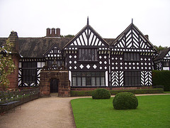  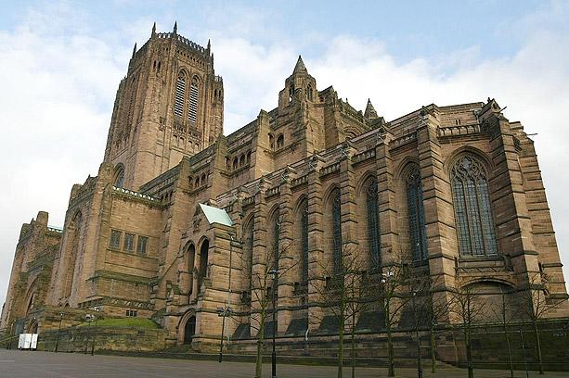 | Liverpool is a city rich in culture. From its beginnings with the history of seafaring from worldwide trade to the great liners of the twentieth century, Liverpool has attracted many of those who had money to invest in both civic buildings to art collections. In the later (20th of course it became known for being the home of Merseybeat and the Liverpool Sound at the famous Cavern Club. All of this history is now preserved within the Maritime Museum and the regenerated dock area which now houses Tate Liverpool. The Walker Art Gallery houses a great and varied collection of paintings from early (14th (Simone Martini) through Poussin to Cezanne and contemporary painting. The building itself is an impressive (19th Neoclassical design and stands with the Picton Library and St Georges Hall (Elmes and Cockerell) as a monument to the wealth of (19th merchant class. This is further evident in the Lady Lever Gallery which houses a fine collection of Victorian and Pre Raphaelite painting and sculpture. A small classical temple in the centre of a model village built by the Lever family.

Speke Hall is one of the best examples of a tudor house in Britain and draws a huge amount of visitors. Then of course there are the two cathedrals, the town hall, the Beatles trail, Mersey river cruises and even Liverpool football club (Anfield) which do tours! It is a city which has recently been th focus of a vast amount of investment and which has been named City Of Culture '08.

Accommodation | Hotel *** Single room supplement £120
Centrally located 2 or 3 star hotel. Bed and Breakfast tariff in twin-share room with private facilities.
Course Cost | £300
Inclusive of tuition, accommodation and breakfast.
Travel Insurance
Please make own arrangements if you require insurance
Travel | Train from London Euston to Liverpool Lime Street
Once the tour is viable you can arrange your own travel, the meeting time with the tutor is at 15.00 hrs at the hotel and you should expect the programme to finish around 13.00 hrs on last day. The train journey takes 2hrs 30 minutes.
Local Transport
Hotel transfers either on foot or short taxi ride at own expense
Group Size | 10
Tutor(s) | Jackie Parry
Related OU Courses | General Interest/A216/AA315

Itinerary
DAY 01
Arrival in Liverpool and Orientation : 19th Century Liverpool, 1960’s and modern Liverpool.
DAY 02
Am Tate Liverpool
Pm Speke Hall
DAY 03
Am Walker Art Gallery
Pm Lady Lever Gallery
DAY 04
Am Cathedral (Anglican and Metropolitan
Pm departure
This itinerary and study programme is provisional and may be subject to change in response to local conditions

Siragusa Tours Ltd, Unit 26, JBJ Business Park,
Northampton Rd, Blisworth, Northants, NN7 3DW
Tel: 01604 859491 Fax : 01604 858511
info@siragusatours.co.uk www.siragusatours.co.uk

