Ravenna, Rimini and Urbino

Byzantine Art and the Renaissance Court
18 - 23 October 2010

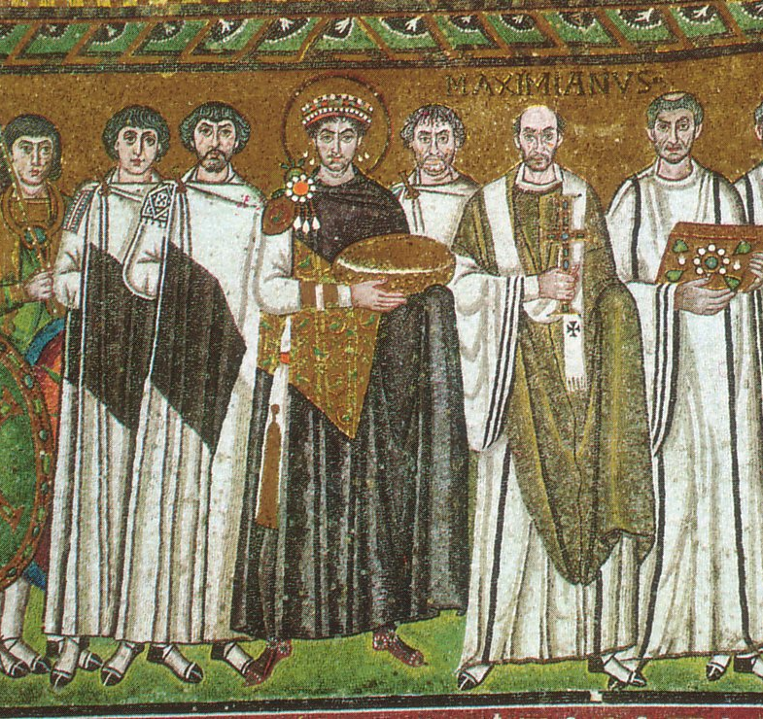  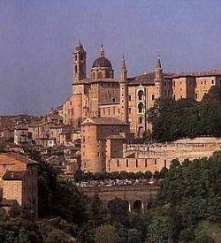  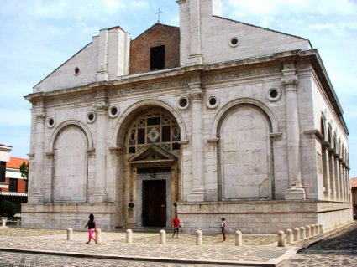 | RAVENNA is a unique centre in Western Europe for the study of Byzantine culture and art. It is now famed for its magnificent Roman and Byzantine architecture and exquisite 5th and 6th century mosaics. Ravenna’s greatest period began in the 5th century when Honorius moved the imperial court from Rome to Ravenna and he and his sister, Galla Placidia, adorned the city with magnificent buildings and exquisite mosaics. After the Goths occupied Ravenna in the late 5th century, Odoacer (473-93) and Theodoric (493-526) continued the grand building programme. In 540 Ravenna was captured by General Belisarius for the Eastern Empire, and the city prospered even further under the rule of Justinian and his empress Theodora.  URBINO, located in a splendid position set deep amidst rolling hills, came to prominence in the late 12th century under Montefeltro rule. In 1443 Oddantonio da Montefeltro was made the first duke of Urbino, and after his death in 1444 his illegitimate half-brother Federico succeeded him. Federico became one of the most important patrons of the Renaissance. Raphael, Bramante, Laurana, Pisanello, Piero della Francesca all worked at Urbino. The magnificent Palazzo Ducale is still one of the finest Renaissance palaces in Italy. It now houses the Galleria Nazionale delle Marche and contains important regional works as well as paintings by Piero della Francesca, Raphael and Titian. Urbino’s fame continued after Federico’s death in 1482 under the rule of his son Guidobaldo and his wife Elisabetta Gonzaga. It was during Guidobaldo’s rule that Castiglione wrote Il cortegiano (The Book of the Courtier), a portrait of Urbino at the pinnacle of its wealth and importance which did so much to spread the fame of this small city.  RIMINI preserves notable remains from its Roman past, amongst which is the c27 BC Arch of Augustus. In the 13th century Malatesta di Verucchio founded the ruling dynasty of Rimini, the most famous of whom was Sigismondo Malatesta (1417-68). In 1447 Sigismondo commissioned Alberti to turn the parish church of San Francesco into the Malatesta family church and mausoleum. Alberti’s innovative classical design appeared so pagan that the church became known as the Tempio Malatestiano. It contains frescoes by Piero della Francesca and superb low-relief sculpture by Agostino di Duccio.

Accommodation | Hotel *** Single room supplement £120
Centrally located Hotels in Ravenna and Urbino. Bed and breakfast tariff in twin-share room with private facilities
Course Cost | £665
Inclusive of tuition, airport transfers (airport transfers are only available for the Siragusa Ltd nominated flight), transfer to Urbino, visit to Rimini, accommodation and breakfast.
Travel Insurance
Once tour is viable and if we have booked a flight for you through Travelpack, you can call Larraine on 08444 930465 for an immediate quote (unless you already have insurance)
Flight | Ca. £190 scheduled flight to Bologna
Note that the cost is an estimate and if it is less you pay less. Please see Booking Conditions for more information concerning nominated flights
Local Transport
Airport transfers and transfer to Urbino by coach
Group Size | 16
Tutor | Daphne Joynes
Daphne Joynes BA, is an experienced lecturer and art historian who has led many gallery study days, Studytours and group visits to Italy. She has taught art history at a number of institutions including Surrey University and lectures for organisations such as NADFAS and the National Trust. Daphne teaches with the Open University, her main area of interest is the early Italian Renaissance and she is currently engaged on research related to early Italo-Byzantine painting.
Related OU Courses | General Interest/AA315/A216

Itinerary
DAY 01
Arrival at Bologna airport, transfer to Hotel in Ravenna. Course introduction and orientation, San Giovanni Evangelista
DAY 02
Am: Mausoleum of Galla Placidia, Basilica di San Vitale, National Museum
Pm: Battistero degli Ariani, Domus dei Tappeti di Petra, followed by optional walk to the Mausoleum of Theodoric via Rocca Brancaleone
DAY 03
Am: Battistero Neoniana, Archipiscopal Museum, San Francesco, Dante’s Tomb
Pm: Sant’ Apollinare, Museo d’Arte della Citta and Pinacoteca Communale
DAY 04
Transfer to Urbino. En route visit to the Basilica of Sant' Apollinare in Classe and Rimini. Orientation in Urbino
DAY 05
Am: Palazzo Ducale, Galleria Nazionale delle Marche, San Domenico, Oratorio di San Giovanni Battista
Pm: San Bernardino – Mausoleum of the Dukes
DAY 06
Museo Casa di Raffaello, free time before afternoon departure to Bologna airport
This itinerary and study programme is provisional and may be subject to change in response to local conditions

Siragusa Ltd, Unit 26, JBJ Business Park,
Northampton Rd, Blisworth, Northants, NN7 3DW
Tel: 01604 859491 Fax : 01604 858511
info@siragusatours.co.uk www.siragusatours.co.uk

