Studytour Programme Nov 2009 – Aug 2010
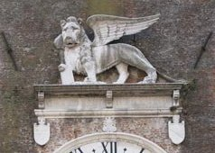
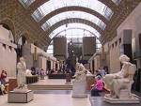 | 20 – 23 November 2009  Paris  Led by Jackie Parry  Course Cost £495 (including Eurostar) OU related courses: AA318/A216/General Interest  VIABLE WITH MORE PLACES AVAILABLE
4 – 8 March 2010
Venice and Torcello
Led by Dr Lyn Rodley
Course Cost £595 (plus flight) OU related courses: AA315/General Interest

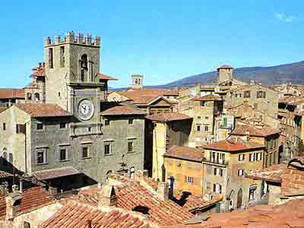 | 11 – 16 March 2010  Cortona, Assisi and Arezzo on half board basis, with optional cook classes  Led by Mary Hawkins  Course Cost £870 (plus flight) OU related courses: General Interest/AA315
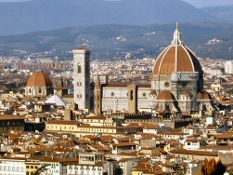 | 16 – 22 April 2010  Renaissance Florence and Siena  Led by Mary Hawkins  Course Cost £695 (plus flight) OU related courses: AA315/A216/General Interest
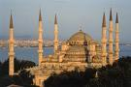 | 21 – 27 April 2010  Istanbul  Led by Dalila Castelijn  Course Cost £695 (plus flight) OU related courses: General Interest  FULLY BOOKED
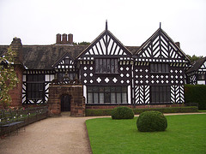 | 1 – 4 May 2010  Liverpool  led by Jackie Parry and limited to 10 people  Course Cost £300 (plus train) OU related courses: General Interest/A216/AA315
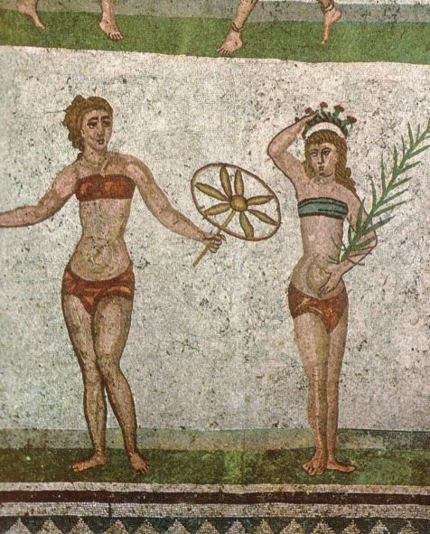 | 19 - 25 May 2010  Sicily: Heritage, History and Art, led by Dr Neil Faulkner  Course Cost £825 (plus flight)  OU related courses: General Interest/Classics/A219  VIABLE WITH MORE PLACES AVAILABLE
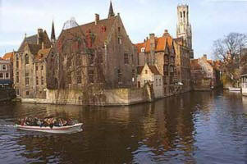 | 2 – 7 June 2010  Bruges, Antwerp and Ghent, led by Mary Hawkins  Course Cost £665 (includes Eurostar)  OU related courses: A216/AA315/General Interest
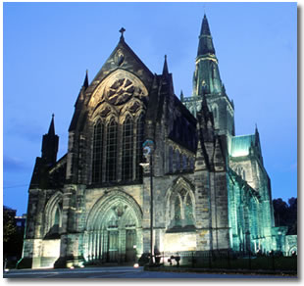 | 17 – 21 June 2010  Glasgow, led by Mary Hawkins  Course Cost £415 (plus train or flight)  OU related courses: General Interest
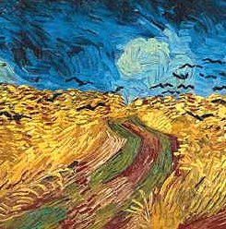 | 27 – 30 August 2010  Amsterdam, led by Jackie Parry  Course Cost £490 (plus flight)  OU related courses: General Interest/A216
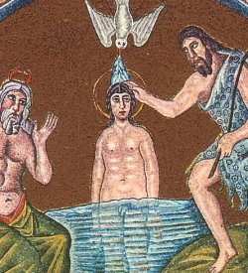 | 18 – 23 October 2010  Ravenna, led by Daphne Joynes  Course Cost £665 (plus flight)  OU related courses: General Interest/AA315/A216
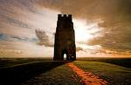 | 26 - 30 October 2010  Glastonbury, Soul’s Journey Tour, led by Chrissy Holmes  Course Cost £515 (plus travel)  For those interested in ‘spiritual growth’

