Venice and Torcello
4 – 8 March 2010
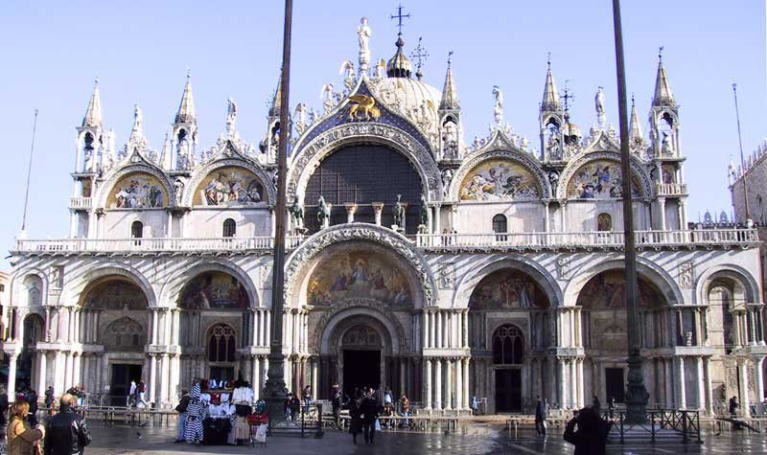  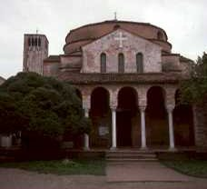  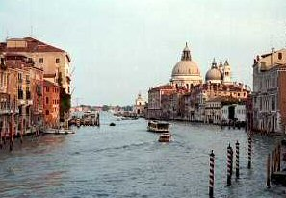 | The water-bound location of Venice placed considerable constraints upon its architects, but facilitated the work of building ships, and it was this that gave the city its power, wealth and cosmopolitan character.  The aristocracy of rich merchants built their palaces along the main canals, both for ease of water transport to their wharves and warehouses, and for the light and air denied to the tall buildings behind them, densely packed along narrow streets and alleys to make the most of limited space. Confraternity houses and the urban monasteries of the mendicant orders dispensed spiritual guidance and charity to a polyglot community which always included foreign traders and entrepreneurs.  The Venetian ships brought back the culture of other lands along with their cargoes: Gothic and Islamic arches decorate palace facades, and San Marco was modelled on a Byzantine church (and later decorated with spoils from the Crusader sack of Constantinople in 1204, an event made possible by the Venetian fleet).

Accommodation | Hotel *** Single room supplement £150
Centrally located Hotel Diana in Venice. Bed and Breakfast tariff in twin-share room with private facilities
Course Cost | £595
Inclusive of tuition, airport transfers (airport transfers are only available for the Siragusa Ltd nominated flight), accommodation and breakfast.
Travel Insurance
Once tour is viable and if we have booked a flight for you through Travelpack, you can call Larraine on 08444 930465 for an immediate quote (unless you already have insurance)
Flight | Ca. £190 scheduled flight to Venice
Note that the cost is an estimate and if it is less you pay less. Please see Booking Conditions for more information concerning nominated flights
Local Transport
Airport transfers by boat
Group Size | 16
Tutor(s) | Dr Lyn Rodley
Related OU Courses | AA315/General Interest

Itinerary
DAY 01
Arrival at airport, transfer to Hotel and orientation
DAY 02
Am: San Marco (inc. Treasury)
Pm: Icon Museum, Scuola di San Giorgio degli Schiavoni
DAY 03
am: Churches walk – to include San Giovanni in Bragora; San Zaccaria; Santa Maria Formosa; Santi Giovanni e Paolo; Santa Maria dei Miracoli; Santa Maria dei Frari
pm: Accademia
DAY 04
Am: Torcello, lunch in Burano
Pm: Ca’d’Oro
DAY 05
am: walk: Cannaregio and the Ghetto
pm: departure for airport
This itinerary and study programme is provisional and may be subject to change in response to local conditions

Siragusa Ltd, Unit 26, JBJ Business Park,
Northampton Rd, Blisworth, Northants, NN7 3DW
Tel: 01604 859491 Fax : 01604 858511
info@siragusatours.co.uk www.siragusatours.co.uk

