Byzantine Thessalonike, 7 – 11 April 2011

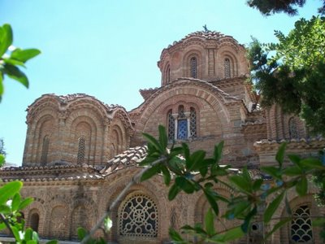
Description
This trip focuses on the Byzantine monuments of Thessalonike, from the early 4th century to the 14th century. We shall visit the Vlattadon Monastery, 14th Ct, with fine views across Thessalonike from its grounds. The Rotunda and Galerian complex is the main late Roman site of Thessalonike – the palace complex of the Roman Tetrarch Galerius (early 4th Ct AD). In the 5th Ct his huge mausoleum was turned into a church and is decorated with some of the earliest surviving Christian mosaics. The Acheiropoietos is a beautiful mid-5th Ct basilica with a little of its original mosaic decoration. Hagia Sophia is an 8th Ct domed church, built during the period of iconoclasm and showing the change in style of Byzantine church architecture after the 6th Ct; it has mosaics of the 8th Ct and later. The Byzantine museum is one of the best in Greece. In the upper town we shall look at the substantial remains of the city walls and the beautiful little monastery church of Nikolaos Orphanos, with fine 14th Ct painting. We shall also visit Hosios David, a small cruciform church with mosaic of the 5th or early 6th Ct. Getting around will be on foot, so be prepared to do quite a lot of walking, some of it uphill.

Other Details

Accommodation
Centrally located Hotel Pella** , Bed and Breakfast tariff in twin-share room with private facilities.

Course Cost
£460 inclusive of tuition, airport transfers (airport transfers are only available for the Siragusa Tours Ltd nominated flight), transfer, accommodation and breakfast.

Single Room Supplement
£100

Travel Insurance
Once tour is viable and if we have booked a flight for you through Travelpack, you can call Larraine on 08444 930465 for an immediate quote (unless you already have insurance)

Flight
Ca. £190 scheduled flight out to Thessalonike. Note that this is an estimate (if it is less you play less), please see Booking Conditions for more information concerning nominated flights.

Local Transport
Airport transfers by coach

Group Size
16

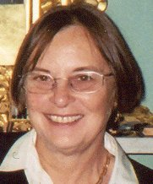
Tutor
Dr Lyn Rodley is a specialist in Byzantine art and author of Byzantine Art and Architecture. An Introduction (CUP 1994). She has taught for the OU and other UK universities for 25 years and was Helen Waddell Visiting Professor at Queen's University Belfast, 2002-06. Courses taught for the OU include A216, A354 and, currently, AA315. She has also led many art study tours, especially to Greece and Turkey. Lyn escapes from her desk occasionally to make pottery in a studio at the bottom of her garden.

Related OU Courses
General Interest

Itinerary / Study Programme

Day 1, Thursday, 7 April 2011
Arrival in Thessalonike, transfer to Hotel
Walk in the upper town and Vlattadon Monastery

Day 2, Friday, 8 April 2011
Am Rotunda and Galerian complex ( lunch in Rotunda area)
Pm H Demetrios and walk back via Ottoman sites

Day 3, Saturday, 9 April 2011
Am Acheiropoietos and Hagia Sophia (lunch in Rotunda area)
Pm Byzantine Museum (or Archeological Museum), walk back via markets

Day 4, Sunday, 10 April 2011
Am Walls, Nikolaos Orphanos (lunch in the acropolis area)
Pm free time to walk in the upper town, meeting at 16.00 hrs to visit Hosios David

Day 5, Monday, 11 April 2011
Am free time until departure

This itinerary and study programme is provisional and may be subject to change in response to local conditions

Siragusa Tours Ltd, Unit 26, JBJ Business Park, Northampton Rd, Blisworth, Northants, NN7 3DW
Tel: 01604 859491, Fax : 01604 858511, info@siragusatours.co.uk, www.siragusatours.co.uk

