SIRAGUSA TOURS LTD

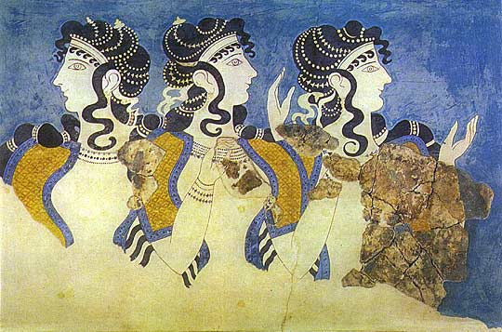
Art History and Classical Studytours

Newsletter, August 2013

Study Tour Programme

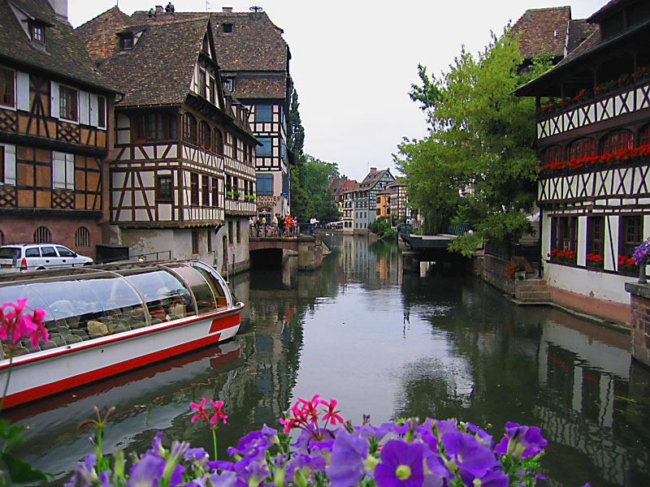 | 7 – 11 November 2013  Strasbourg and Colmar  Led by Mary Hawkins  Course Cost £475 (plus flight)  OU related courses: General Interest / Art History Courses  VIABLE and more places available
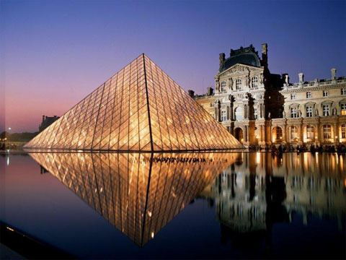 | 15 - 18 November 2013  Paris: Modern Art  Led by Jackie Parry  Course Cost £545 (including Eurostar)  OU related courses: AA318/A226/General Interest
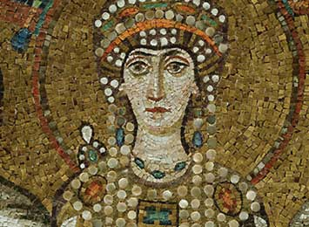 | 15 – 19 November 2013  Ravenna  Led by Daphne Joynes  Course Cost £495 (plus flight)  OU related courses: General Interest/AA315/A226  VIABLE and more places available
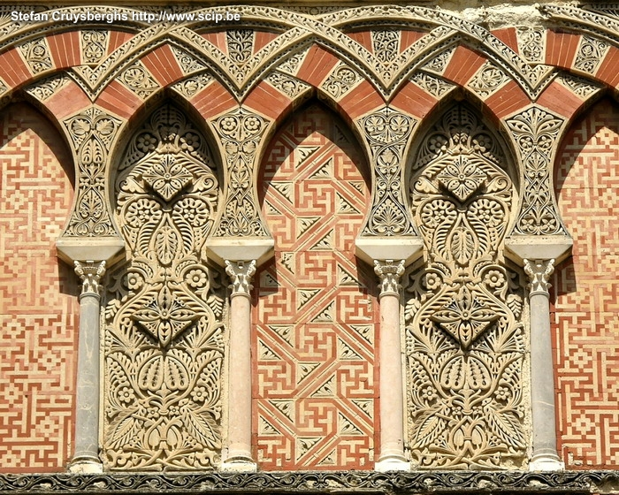 | 24 November - 1 December 2013  Granada, Cordoba & Seville: In the Steps of the Moors  led by Mary Hawkins  Course Cost £755 (plus flight)  OU related courses: General Interest  VIABLE and more places available
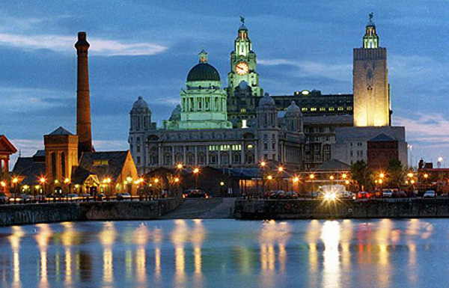 | 14 – 17 March 2014  Liverpool  Led by Jackie Parry  Course Cost £325 (plus travel)  OU related courses: General Interest/A226/AA315
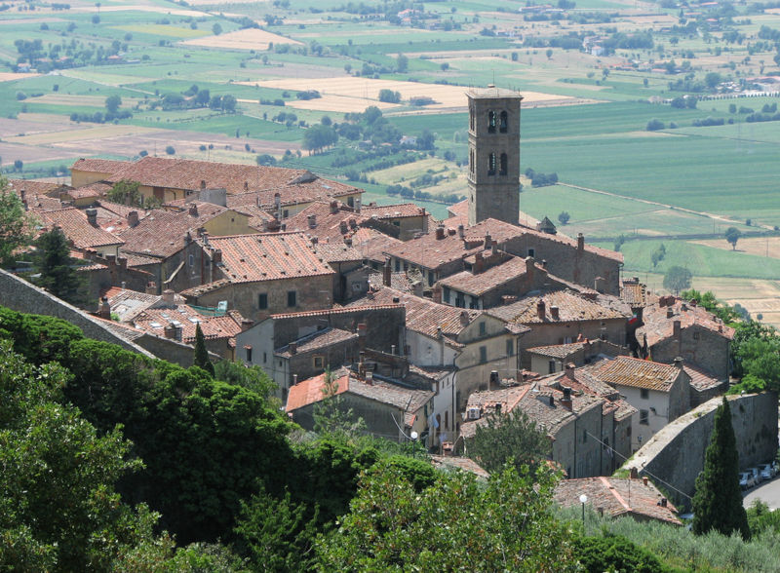 | 2 – 7 April 2014  Cortona, Assisi and Piero della Francesca  led by Mary Hawkins  Course Cost £865 on half board basis (plus flight)  OU related courses: General Interest/AA315
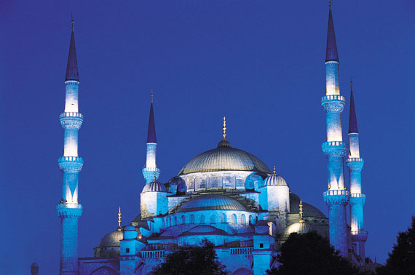 | 8 - 14 April 2014  Istanbul and Cappadocia  led by Dalila Castelijn  Course Cost £665 (plus flight)  OU related courses: General Interest
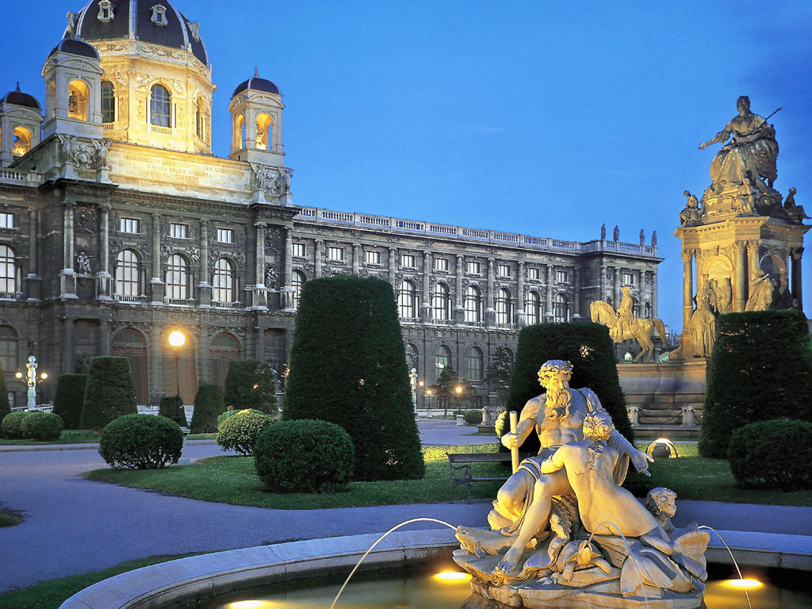 | 8 – 12 May 2014  Vienna  Led by Jackie Parry  Course Cost £575 (plus flight)  OU related courses: General Interest
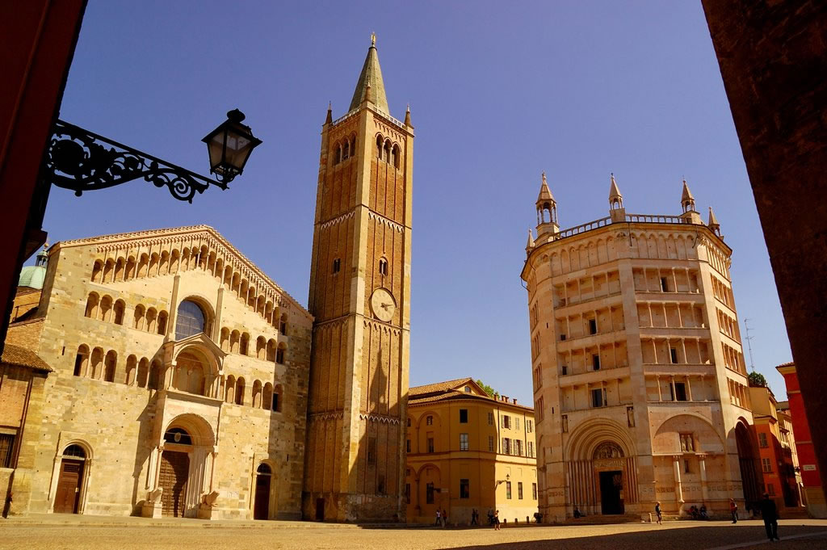 | 23 - 28 May 2014  Modena, Parma and Piacenca  Led by Mary Hawkins  Course Cost £645 (plus flight)  OU related courses: General Interest/AA315/A226
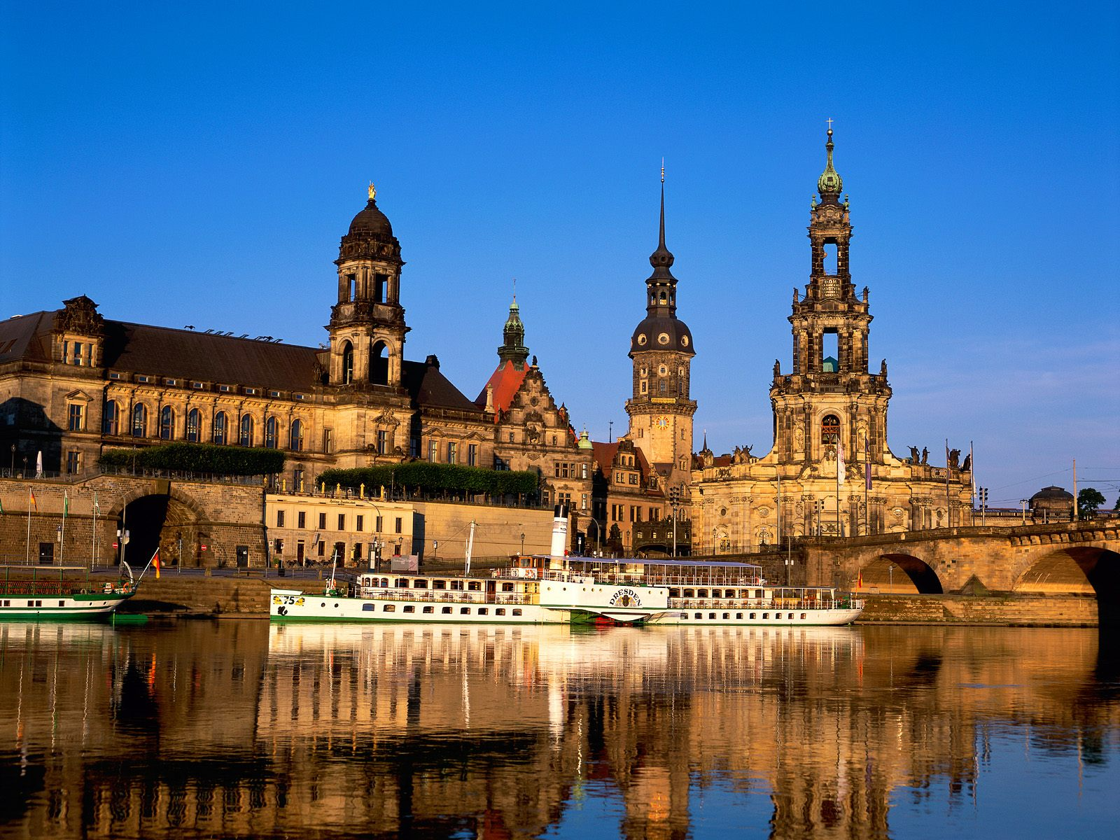 | 5 – 9 June 2014  Dresden and Meissen  Led by Jackie Parry  Course Cost £455 (plus flight)  OU related courses: General Interest/A226/AA315/AA318

GRANADA, CORDOBA AND SEVILLE: In the Footsteps of the Moors,
led by Mary Hawkins, 24 November – 1 December 2013
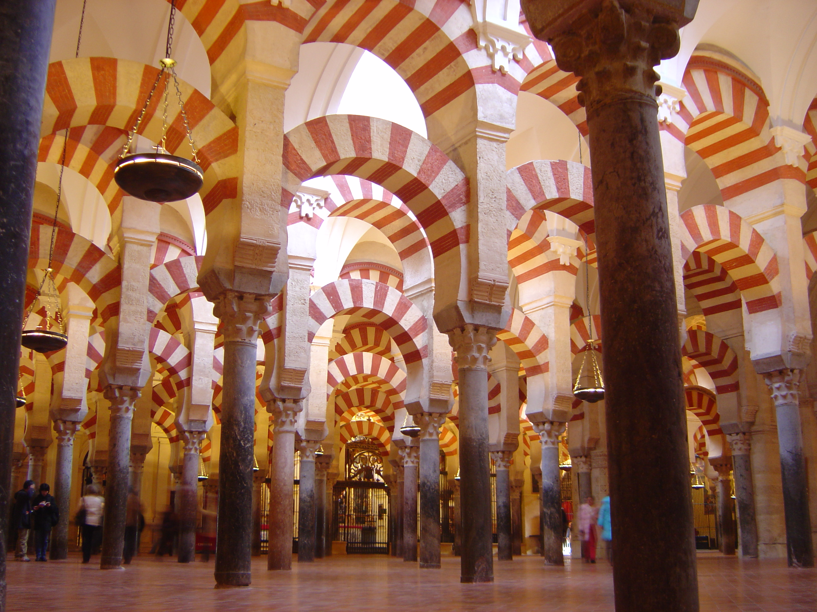
There are many good reasons for visiting Islamic Spain - the great monuments such as the Alhambra in Granada, the mosque (Mezquita) in Cordoba and the Giralda Tower and Alcazar in Seville. By the 9th century, almost all Spain was Islamic - a situation which existed until the Christian advance ended in 1492 with the final surrender of the Arabs. These 3 cities reflect the Arab occupation, but there are also, in each, superb and interesting buildings of later dates - Granada's Cathedral houses the tombs of the Catholic Kings, Isabella and Ferdinand who unified Spain, and there are also the glorious gardens of the Generalife. In Seville there is the so-called House of Pilate and in the Museo del Bellas Artes, a superb collection of Spanish paintings. Our travel between the cities will involve interesting journeys through beautiful Andalucia. There are more places available for this tour, please get in touch if you are interested.

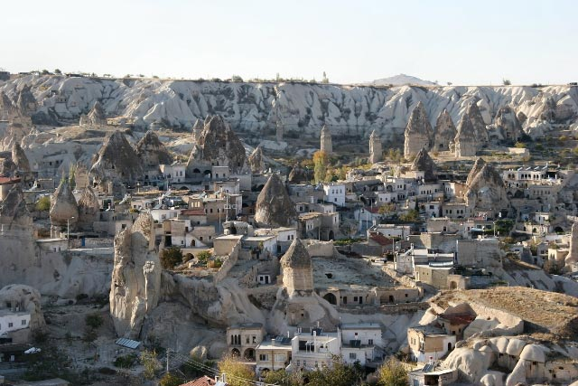
NEW EXCITING TOUR TO ISTANBUL AND CAPPADOCIA
8 – 14 April, led by Dalila Castelijn
Cappadocia is a fascinating area with spectacular landscapes. They have incredible accommodation called ‘Cave Hotels’ which are built into the rocks. The hotels are usually small and require an instant deposit to make a reservation. If you are interested in this tour please let us know as soon as possible so that the necessary arrangements can be made in good time.

Cappadocia, in the Turkish region of central Anatolia, is the ancient land of the Hittites, later colonized by the Romans and where for hundred of years men dug into the soil to create houses and monasteries churches and cities. The tour focuses on highlights of the region such as Goreme Valley rock churches, Uchisar rock citadel, the Fairy Chimneys of Devrent Valley, the Byzantine chapels of the Ihlara Valley and the underground cities of Kaymakly and Derinkuyu.

TOURS LATER IN 2014

Manchester, 17 – 20 Oct 2014, led by Jackie Parry – Mantua & Ferrara, 22 – 26 Oct 2014 led by Daphne Joynes – Trieste, Nov 2014 led by Mary Hawkins – Segovia, Avila & Salamanca, Nov 2014, led by Mary Hawkins – Lyon, Nov 2014, led by Jackie Parry – New York, Dec 2014, led by Jackie Parry.

Please get in touch to express interest in any of these destinations.

Gallery and Museum Visits

26 Oct  2013 | Myth in the Greek World,  British Museum, London | A330/General Interest | Dr Sue Blundell | 11:00 – 13:00 | £17.50
26 Oct 2013 | Myth in the Roman World,  British Museum, London | A330/General Interest | Dr Sue Blundell | 14:00 – 16:00 | £17.50
7 Dec  2013 | Sandro Botticelli,  National Gallery, London | A226/General Interest | Mary Hawkins | 11:00 – 13:00 | £17.50
7 Dec  2013 | El Greco: From Crete to Toledo, National Gallery, London | A226/General Interest | Mary Hawkins | 14:00 – 16:00 | £17.50
25 Jan 2014 | UNDERSTANDING RENAISSANCE ART No 1, 1300 - 1400 Making and Meaning, NG, London | AA315/A226/  General Interest | Daphne Joynes | 11:00 – 13:00 | £17.50
25 Jan 2014 | UNDERSTANDING RENAISSANCE ART No 2, 1400 - 1600 Continuity and Change, NG, | AA315/A226/  General Interest | Daphne Joynes | 14:00 – 16:00 | £17.50
1 Feb  2014 | Etruscan History and Mythology, British Museum | General Interest/  A219/A330 | Dr William Stirling | 11:00 – 13:00 | £17.50
15 Feb 2014 | Renaissance Altarpieces, National Gallery, London | AA315/A226/General Interest | Mary Hawkins | 11:00 – 13:00 | £17.50
15 Feb 2014 | Netherlandish Painting, National Gallery, London | AA315/A226/General Interest | Mary Hawkins | 14:00 – 16:00 | £17.50
1 March 2014 | The Enlightenment, New Ways of viewing the World, British Museum, | General Interest /A200 | Dr William Sterling | 11:00 – 13:00 | £17.50
8 March 2014 | The Wallace Collection: An International Treasurehouse (18th Century French Painting) | A226/General Interest | Jackie Parry | 11:00 – 13:00 | £17.50
8 March 2014 | Impressionism, National Gallery London | AA318/A226/General Interest | Jackie Parry | 14:30 – 16:30 | £17.50
15 March 2014 | UNDERSTANDING RENAISSANCE ART No 3, Aspects of Patronage. NG | AA315/A226/  General Interest | Daphne Joynes | 11:00 – 13:00 | £17.50
15 March 2014 | UNDERSTANDING RENAISSANCE ART No 4, How Portraiture Developed. NG | AA315/A226/  General Interest | Daphne Joynes | 14:00 – 16:00 | £17.50
5 April 2014 | Medieval to Modern: Changes in Techniques and Subjects, British Museum, London | General Interest /A200 | Dr William Sterling | 11:00 – 13:00 | £17.50
26 April 2014 | Victorian Painting,  Tate Britain, London | A226/General Interest | Jackie Parry | 11:00 – 13:00 | £17.50
26 April 2014 | PreRaphaelite Brotherhood,  Tate Britain, London | A226/General Interest | Jackie Parry | 14:00 – 16.00 | £17.50
17 May 2014 | Cubism and Abstract Art,  Tate Modern, London | A226/AA318/General Interest | Jackie Parry | 11:00 – 13:00 | £17.50
17 May 2014 | Abstract Expressionism and Conceptual Art, Tate Modern, London | A226/AA318/General Interest | Jackie Parry | 14:00 – 16:00 | £17.50
24 May 2014 | William Morris Gallery, Lloyd Park in Walthamstow, London | A226/General Interest | Jackie Parry | 11:00 – 13:00 | £17.50
24 May 2014 | William Morris at the Victoria & Albert Museum, London | A226/General Interest | Jackie Parry | 14:30 – 16:30 | £17.50

TUTORS: The tutors for these Gallery and Museum Visits are all experienced Lecturers who have been selected for their skills in communication and teaching. They are able to direct attention to study issues whether at an introductory or advanced level. Siragusa Tours Ltd reserves the right to substitute a named tutor. Tutors/Lecturers will be identified by a badge displaying their name.

GROUP SIZE: For Gallery/Museum Visits the number of participants will usually be no more than 15. This is to ensure the maximum benefit for all participants.

CANCELLATIONS: If Siragusa Tours Ltd is obliged to cancel a particular Gallery/Museum Visit, a full refund will be made. If you are unable to participate and cancel before the event you will receive a voucher to be used at another similar event or you can choose an alternative visit.

MEETING POINTS FOR GALLERY VISITS
National Gallery: ‘Meeting Point’ beside the Information Desk in the Sainsbury Wing
National Portrait Gallery: By the entrance
V&A: Group Entrance in Exhibition Road

Courtauld Institute (Somerset House, The Strand): Under portico outside gallery entrance

Tate Modern: In the Turbine Hall by the Information Desk

Tate Britain: Manton group entrance on Atterbury Street
British Museum: In the Great Court by the Information Desk
Estorick Collection: By the entrance
Wallace Collection: By the entrance
William Morris Gallery (Lloyd Park, Walthamstaw, London): By the Entrance

Siragusa Tours Ltd, Unit 26, JBJ Business Park, Northampton Rd, Blisworth, Northants NN7 3DW
Tel 01604 859491 Fax 01604 858511 info@siragusatours.co.uk www.siragusatours.co.uk

Gallery and Museum Visits Booking Form

Mr/Mrs/Ms
Address
 |  | Post Code
Phone | Mobile
E-mail
OU Course(s)
Date | Time | Location | Course | Places | Total
 |  |  |  |  | £
 |  |  |  |  | £
 |  |  |  |  | £
 |  |  |  |  | £
 |  |  |  |  | £
 |  |  |  |  | £
 |  |  |  |  | £

I enclose a cheque made payable to Siragusa Tours Ltd for £

