***SIRAGUSA TOURS LTD***

*Art History and Classical Studytours*

*Newsletter, May 2015*

***Study Tour Programme***

|  |  |
| --- | --- |
|  | 28 May – 1 June 2015  **Krakow**  Led by Mary Hawkins  Course Cost £455 (plus flight)  OU related courses: General Interest  **VIABLE and only 3 places left** |
|  | 4 - 8 June 2015  **Paris, Versailles and Giverny**  Led by Jackie Parry  Course Cost £675 (includes Eurostar)  OU related courses: AA318/A226/General Interest  **VIABLE and more places available** |
|  | 24 – 28 September 2015  **Palma de Mallorca and Soller**  Led by Jackie Parry  Course Cost £515 (plus flight)  OU related courses: General Interest |
| http://ts1.mm.bing.net/th?&id=HN.607990305135460396&w=300&h=300&c=0&pid=1.9&rs=0&p=0 | 22 – 28 October 2015  **Washington**  Led by Jackie Parry  Course Cost £825 / £865 / £1185 depending on room requirements (plus flight)  OU related courses: AA318/A226/General Interest  **VIABLE and more places available** |
| http://ts1.mm.bing.net/th?&id=HN.608004122036012542&w=300&h=300&c=0&pid=1.9&rs=0&p=0 | 26 October – 1 November 2015  **Renaissance Rome and Orvieto**  Led by Dalila Castelijn  Course Cost £675  OU related courses: AA315/General Interest |
| http://www.imercatinidinatale.com/wp-content/uploads/2010/11/Bologna.jpg | 8 – 12 November 2015  **Bologna and Modena**  Led by Daphne Joynes  Course Cost £490  OU related courses: AA315/A226/General Interest  **VIABLE and more places available** |
| http://www.maltahotels.com.mt/data/401/unknow_general/la_valletta_malta_1_.jpg | 18 – 23 November 2015  **Malta**  Led by Mary Hawkins  Course Cost £690  OU related courses: General Interest  **VIABLE and 7 more places available** |
| http://www.travelplan.it/img/ravenna03.jpg | 24 – 29 February 2016  **The Art of Byzantine Ravenna, Renaissance Rimini and the Court of Urbino**  Led by Daphne Joynes  Course Cost £595 (plus flight)  OU related courses: General Interest/AA315/AA226 |
| http://www.malaga-andalusien.de/bildergalerie/hafen-malaga.jpg | 25 Feb – 1 March 2016  **Malaga and Nerja**  Led by Jackie Parry  Course Cost £655 (plus flight)  OU related courses: A226/AA318/General Interest |
| http://media-cdn.tripadvisor.com/media/photo-s/03/9b/30/16/reykjavik.jpg | 18 – 24 March 2016  **Iceland**  Led by Mary Hawkins  Course Cost £1305 (plus flight)  OU related courses: General Interest |

**FURTHER TOURS FOR SPRING 2016:**

31 March – 5 April 2016, **Cyprus**, led by Dalila Castelijn

24 – 29 April 2016, **Florence, Pisa and Siena**, led by Peter Murphy

19 – 24 May 2016, **Madrid**, led by Jackie Parry

**Contact us to register your interest in any of these destinations and information will be sent us soon as it is available.**

**ARCHITECTURAL WALK: The Trail of the Great Fire in London,**

**16th July 2015, with Mary Hawkins**

In the 17th century, small outbreaks of fire were common in the City of London as the streets were narrow, wooden houses built close together, and people used candles and fires for light and warmth. But, in the early hours of Sunday, September 2nd 1666, a fire started in a bakery in Pudding Lane which continued for 5 days, destroying hundreds of houses and 87 churches. In the years that followed, new buildings were erected which have, over time, also been replaced. Today on our walk (including a lunch break!) we shall talk about the path of the Great Fire and the buildings that have been constructed since in the area. The Meeting Point: at 11.00 hrs outside the City information Centre between St Paul’s Churchyard and Carter Lane. **Let us know if you would like to reserve a place.**

**COURSE ASSISTANT, WASHINGTON, 22 – 28 October, led by Jackie Pary**

We are looking for a course assistant for our Washington tour. However, please note that for this tour the discount is 20% whereas on the European tours it is 50%. **If you are interested get in touch.**

**ICELAND, 18 -24 March 2016, led by Mary Hawkins**

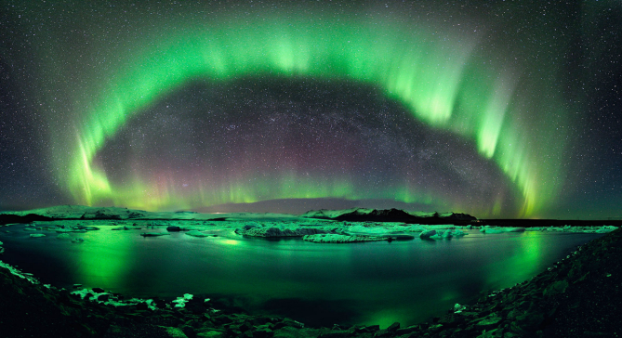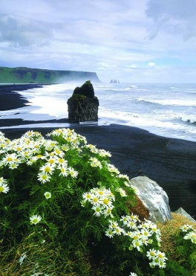This exciting visit to Iceland will involve experiencing a whole range of awe-inspiring natural wonders, some of the most impressive in Europe, for example a coach will take you to the area of the Golden Circle (with the Northern Lights) and the South Shore where we will see gushing geysers, impressive glaciers, barren highlands, high waterfalls, black beaches and the famous thermal pool, the Blue Lagoon. This tour in comparison to others is higher priced because there is so much more included. **We need a minimum of 12 people for this tour to get ahead, so if you are interested get in touch to get the full details.**

***Gallery and Museum Visits***

|  |  |  |  |  |  |
| --- | --- | --- | --- | --- | --- |
| 30 May  2015 | Introduction to the British Museum | General Interest/  AA100 The Arts Past and Present | Dr William Sterling | 11.00 – 13.00 | £17.50 |
| 13 June  2015 | Roman Art and History in the British Museum | A219/A330/General Interest | Dr William Sterling | 11.00 – 13.00 | £17.50 |
| 13 June  2015 | Greek Art and History in the British Museum | A219/A330/General Interest | Dr William Sterling | 14.00 – 16.00 | £17.50 |
| 16 July 2015 | An Architectural Walk: The Trail of the Great Fire in London | General Interest | Mary Hawkins | 11:00 – 15.00 (includes lunch break) | £26 |
| 24 Oct  2015 | Myth in the Greek World,  British Museum, London | A330/General Interest | Dr Sue Blundell | 11.00 – 13.00 | £17.50 |
| 24 Oct 2015 | Myth in the Roman World,  British Museum, London | A330/General Interest | Dr Sue Blundell | 14.00 – 16.00 | £17.50 |
| 5 Dec  2015 | Classical Themes in Painting at the National Gallery | AA315/General Interest | Mary Hawkins | 11.00 – 13.00 | £17.50 |

**TUTORS:** The tutors for these Gallery and Museum Visits are all experienced Lecturers who have been selected for their skills in communication and teaching. They are able to direct attention to study issues whether at an introductory or advanced level. Siragusa Tours Ltd reserves the right to substitute a named tutor. **Tutors/Lecturers will be identified by a badge saying SIRAGUSA TOURS and displaying their name.**

**GROUP SIZE:** For Gallery/Museum Visitsthe number of participants will usually be no more than 16. This is to ensure the maximum benefit for all participants.

**CONFIRMATIONS**: After you have booked on a gallery visit you will receive a confirmation letter with instructions and telephone numbers of the tutors in case you need to contact them on the day.

**CANCELLATIONS:** If Siragusa Tours Ltd is obliged to cancel a particular Gallery/Museum Visit, a full refund will be made. If you are unable to participate and cancel before the event you are entitlet do choose an alternative visit.

**LATE ARRIVAL**: If you arrive late please ask at the information desk about the whereabouts of the group.

**MEETING POINTS FOR GALLERY VISITS**

**National Gallery**: by the **bench opposite** the Information Desk in the Sainsbury Wing

**National Portrait Gallery**: By the entrance

**V&A**: by the Main Entrance Hall

**Courtauld Institute (Somerset House, The Strand)**: Under portico outside gallery entrance

**Tate Modern**: In the Turbine Hall by the Information Desk

**Tate Britain**: Manton group entrance on Atterbury Street

**British Museum**: In the Great Court by the Information Desk

**Estorick Collection**: By the entrance

**Wallace Collection:** By the entrance

**William Morris Gallery** (Lloyd Park, Walthamstow, London): By the Entrance

**John Soane Museum**: By the entrance

***Gallery and Museum Visits Booking Form***

|  |  |  |
| --- | --- | --- |
| Mr/Mrs/Ms | | |
| Address | | |
|  | | |
|  | | Post Code |
| Phone | Mobile | |
| E-mail | | |
| OU Course(s) | | |

|  |  |  |  |  |  |
| --- | --- | --- | --- | --- | --- |
| Date | Time | Location | Course | Places | Total |
|  |  |  |  |  | **£** |
|  |  |  |  |  | **£** |
|  |  |  |  |  | **£** |
|  |  |  |  |  | **£** |
|  |  |  |  |  | **£** |
|  |  |  |  |  | **£** |
|  |  |  |  |  | **£** |

I enclose a cheque made payable to **Siragusa Tours Ltd** for £

Siragusa Tours Ltd, Unit 26, JBJ Business Park, Northampton Rd, Blisworth, Northants NN7 3DW

**Tel 01604 859491 Fax 01604 858511** [**info@siragusatours.co.uk**](mailto:info@siragusatours.co.uk)[**www.siragusatours.co.uk**](http://www.siragusatours.co.uk)