SIRAGUSA TOURS LTD

Art History and Classical Studytours

Newsletter, November 2014

Study Tour Programme

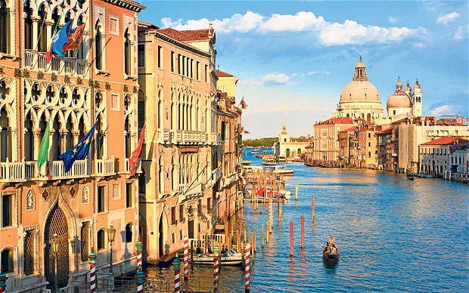 | 2 – 6 March 2015  East Meets West: The Magnificence of Venice  Led by Daphne Joynes  Course Cost £550 (plus flight)  OU related courses: AA315/A226/General Interest
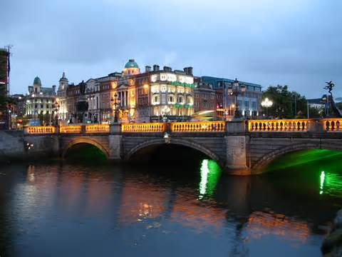 | 27 – 30 March 2015  Dublin  Led by Jackie Parry  Course Cost £425 (plus flight)  OU related courses: Art History Courses / General Interest
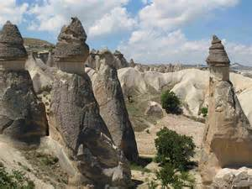 | 8 – 14 April 2015  Istanbul and Cappadocia  led by Dalila Castelijn  Course Cost £665 (plus flight)  OU related courses: General Interest  VIABLE and more places available
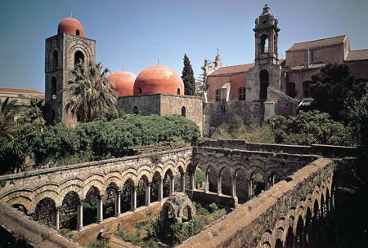 | 23 – 28 April 2015  Byzantine Sicily  Led by Peter Murphy  Course Cost £655 (plus flight)  OU related courses: General Interest  VIABLE and more places available
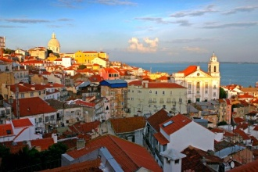 | 7 - 11 May 2015  Lisbon and Sintra  Led by Jackie Parry  Course Cost £525  OU related courses: Art history courses /General Interest
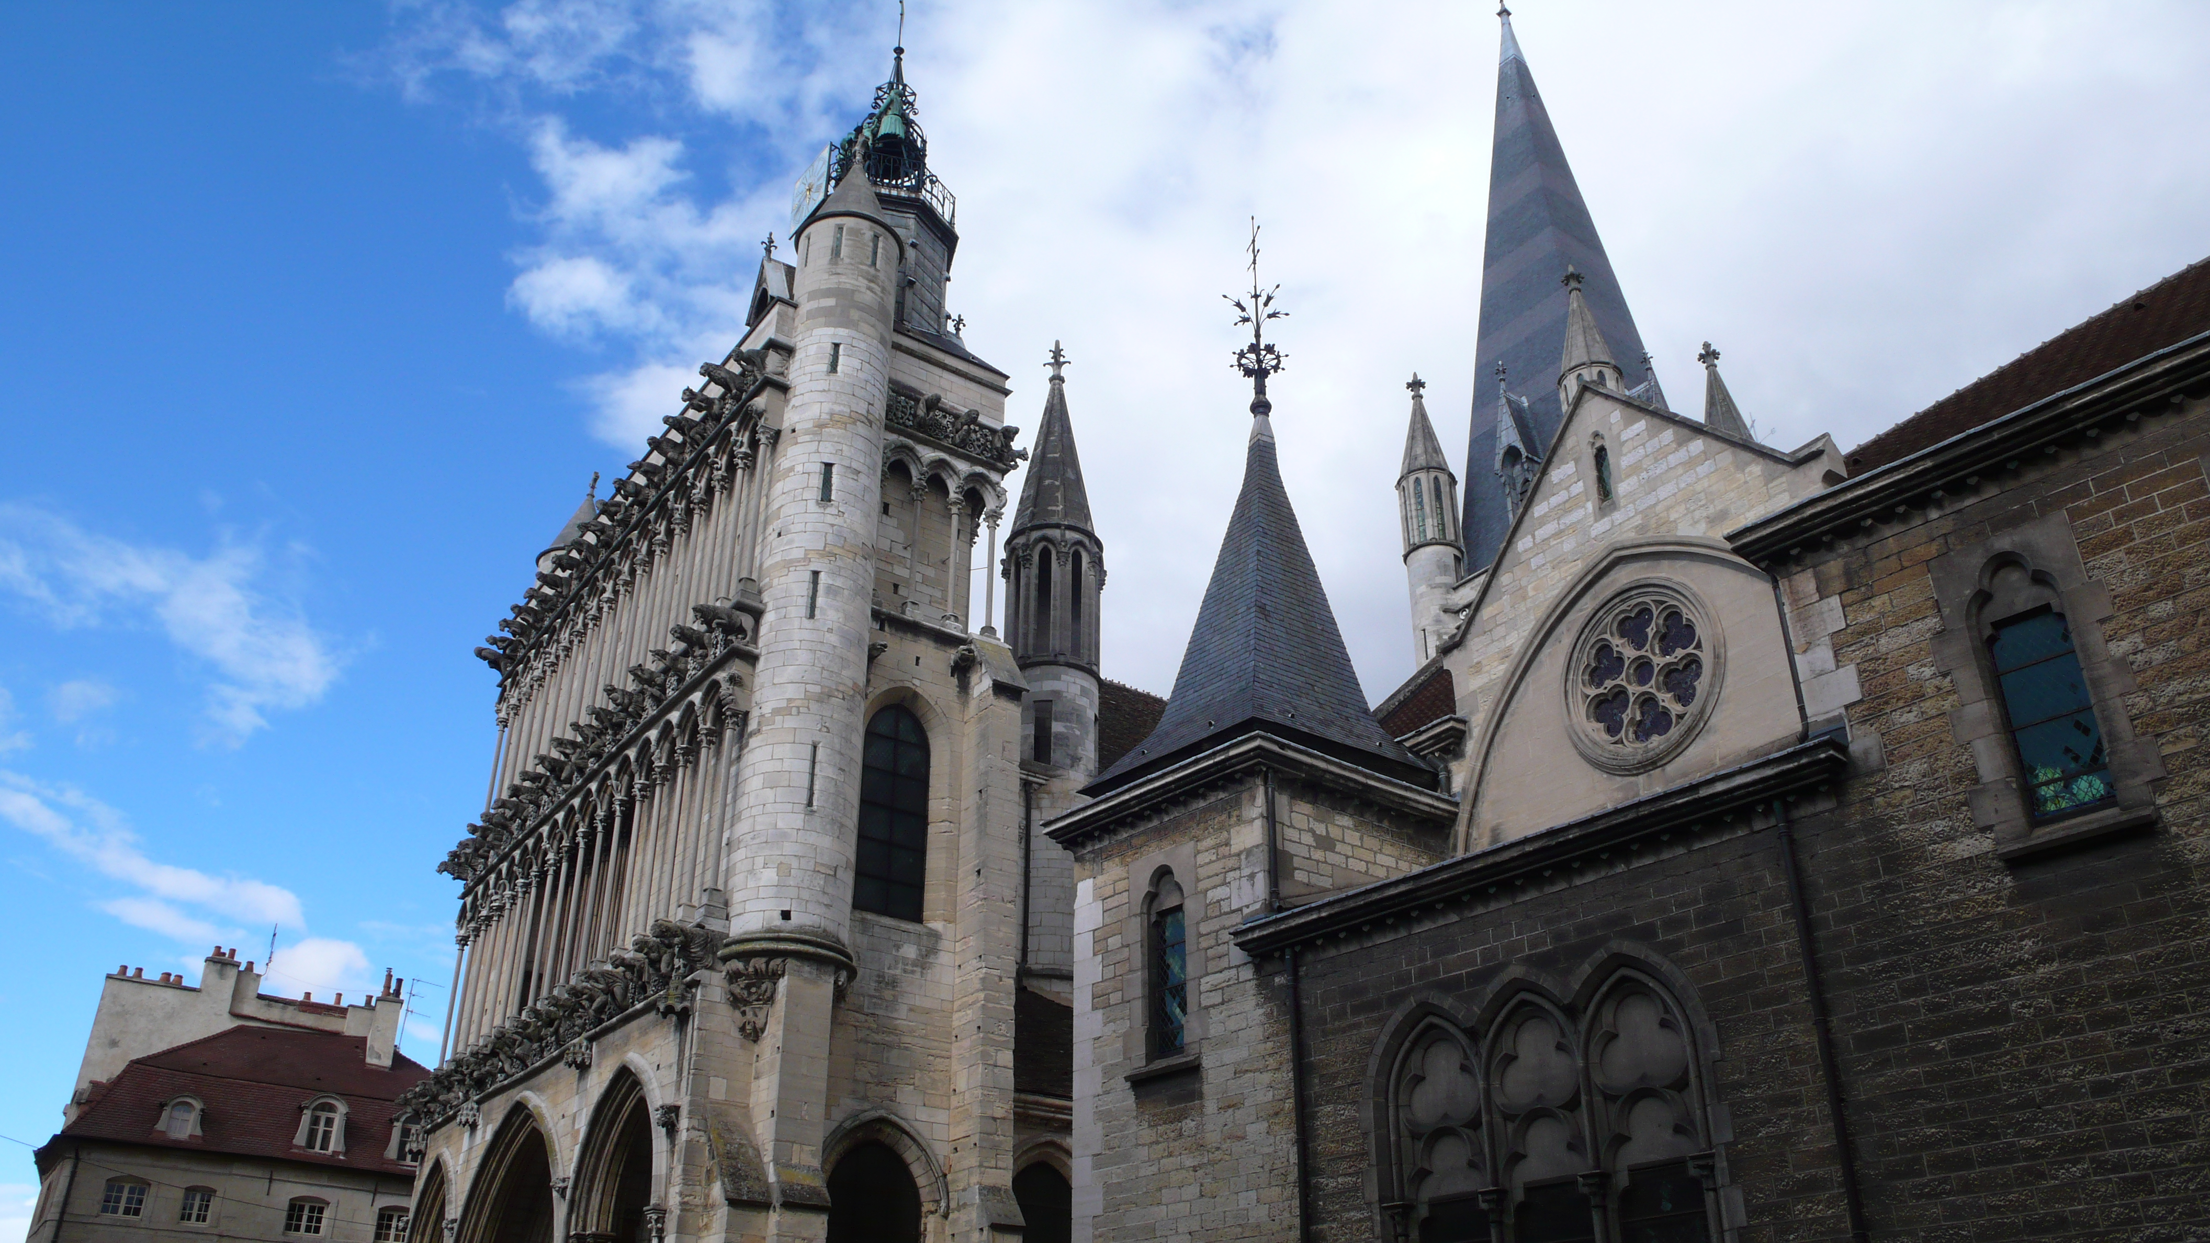 | 21 - 25 May 2015  Burgundy: From Romanesque to Renaissance Art and Architecture  Led by Dalila Castelijn  Course Cost £575  OU related courses: AA315/General interest (specifically medieval art and architecture)  VIABLE AND MORE PLACES AVAILABE
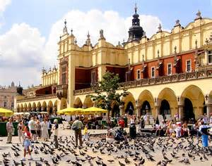 | 28 May – 1 June 2015  Krakow  Led by Mary Hawkins  Course Cost £455 (plus flight)  OU related courses: General Interest  VIABLE and only 4 places left
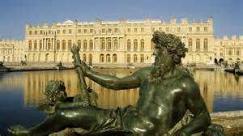 | 4 - 8 June 2015  Paris, Versailles and Giverny  Led by Jackie Parry  Course Cost £675 (includes Eurostar)  OU related courses: AA318/A226/General Interest
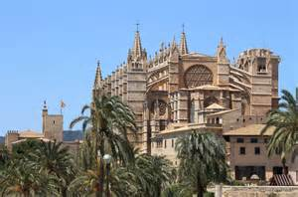 | 24 – 28 September 2015  Palma de Mallorca and Soller  Led by Jackie Parry  Course Cost £515 (plus flight)  OU related courses: General Interest
 | 22 – 28 October 2015  Washington  Led by Jackie Parry  Course Cost £825 / £865 / £1185 depending on room requirements (plus flight)  OU related courses: AA318/A226/General Interest
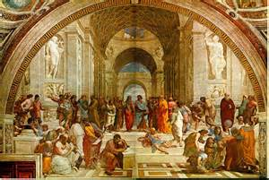 | 21 - 25 May 2015  Renaissance Rome and Orvieto  Led by Dalila Castelijn  Course Cost £675  OU related courses: AA315/General Interest

FORTH COMING TOUR TO VENICE, 2 – 6 March 2014, led by Daphne Joynes
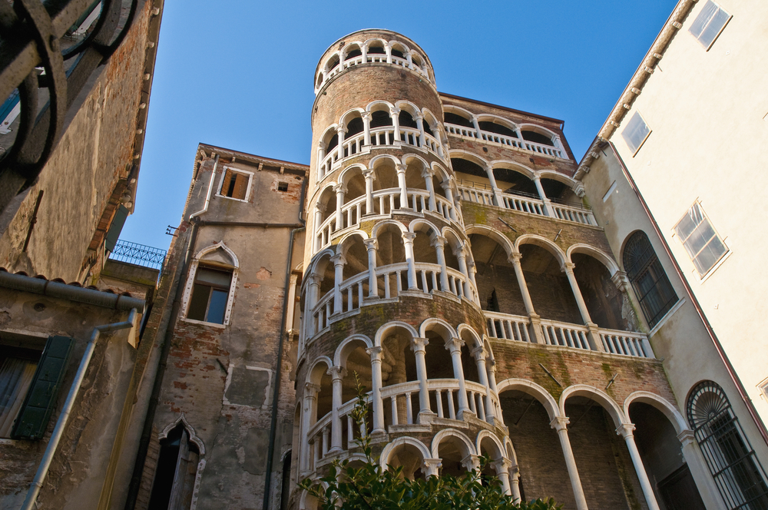
Venetian art has its own special characteristics, and during this study tour we will be able to see what made it unique. We will visit the cathedral of San Marco with its splendid medieval mosaics, and then trace their on-going influence through the work of such great artists as Giovanni and Gentile Bellini, Carpaccio, Titian, Tintoretto and Veronese - in the Palazzo Ducale, the delightful Scuola di San Giorgio degli Schiavoni and the Dominican church of Santi Giovanni e Paolo. We will spend one whole day visiting the lagoon islands of Murano, Torcello and Burano. We will visit the Accademia Gallery which houses the world’s the finest collection of Venetian paintings and the magnificent church of Santa Maria Gloriosa dei Frari, We will also look at the great Palladian churches of San Giorgio Maggiore and the Redentore, on the islands of San Giorgio and La Giudecca. The tour is useful for those of you studying AA315 or AA226, but also for those of you who would like to visit one of the most beautiful cultural towns in the world accompanied by an art historian. Let us know if you are interested.

COURSE ASSISTANT
We need a course assistant for Burgundy, 21 – 25 May 2015. If you are interested please get in touch.

MORE TOURS FOR THE AUTUMN 2015
Bologna 8 – 12 November 2015, led by Daphne Joynes
Malta 18 – 23 November 2015, led by Mary Hawkins
Gallery and Museum Visits
6 Dec  2014 | Sandro Botticelli,  National Gallery, London | A226/General Interest | Mary Hawkins | 11:00 – 13:00 | £17.50
6 Dec  2014 | El Greco: From Crete to Toledo, National Gallery, London | A226/General Interest | Mary Hawkins | 14:00 – 16:00 | £17.50
24 Jan 2015 | UNDERSTANDING RENAISSANCE ART No 1, 1300 - 1400 Making and Meaning, NG | AA315/A226/  General Interest | Daphne Joynes | 11:00 – 13:00 | £17.50
24 Jan 2015 | UNDERSTANDING RENAISSANCE ART No 2, 1400 - 1600 Continuity and Change, NG, | AA315/A226/  General Interest | Daphne Joynes | 14:00 – 16:00 | £17.50
31 Jan  2015 | Etruscan History and Mythology, British Museum | General Interest/  A219/A330 | Dr William Sterling | 11:00 – 13:00 | £17.50
14 Feb 2015 | UNDERSTANDING RENAISSANCE ART No 3, Aspects of Patronage. NG | AA315/A226/  General Interest | Daphne Joynes | 11:00 – 13:00 | £17.50
14 Feb 2015 | UNDERSTANDING RENAISSANCE ART No 4, How Portraiture Developed. NG | AA315/A226/  General Interest | Daphne Joynes | 14:00 – 16:00 | £17.50
21 Feb 2015 | Victorian Painting,  Tate Britain, London | A226/General Interest | Jackie Parry | 11:00 – 13:00 | £17.50
21 Feb 2015 | PreRaphaelite Brotherhood,  Tate Britain, London | A226/General Interest | Jackie Parry | 14:00 – 16.00 | £17.50
7 March 2015 | 17th Century and its Influence on Modernism, NG, London | AA318/A226/General Interest | Jackie Parry | 11:00 – 13:00 | £17.50
7 March 2015 | Impressionism, National Gallery London | AA318/A226/General Interest | Jackie Parry | 14:30 – 16:30 | £17.50
14 March 2015 | Renaissance Altarpieces, National Gallery, London | AA315/A226/General Interest | Mary Hawkins | 11:00 – 13:00 | £17.50
14 March 2015 | Netherlandish Painting, National Gallery, London | AA315/A226/General Interest | Mary Hawkins | 14:00 – 16:00 | £17.50
25 April 2015 | 18th Century and Neo-classical Art, John Soane Museum, London | A226/A318/A207  General Interest | Jackie Parry | 11:00 – 13:00 | £17.50
25 April 2015 | Futurism, Estorick Collection, London | A226/A318/A207  General Interest | Jackie Parry | 14:30 – 16:30 | £17.50  plus entrance
9 May 2015 | UNDERSTANDING RENAISSANCE ART No 5, Viewing and Locating Early Renaissance Sculpture, the V & A | AA315/A226/  General Interest | Daphne Joynes | 11:00 – 13:00 | £17.50
9 May 2015 | UNDERSTANDING RENAISSANCE ART No 6, Viewing and Locating 15th century Italian Sculpture, the V & A | AA315/A226/  General Interest | Daphne Joynes | 14:00 – 16:00 | £17.50
24 Oct  2014 | Myth in the Greek World,  British Museum, London | A330/General Interest | Dr Sue Blundell | 11:00 – 13:00 | £17.50
24 Oct 2014 | Myth in the Roman World,  British Museum, London | A330/General Interest | Dr Sue Blundell | 14:00 – 16:00 | £17.50

TUTORS: The tutors for these Gallery and Museum Visits are all experienced Lecturers who have been selected for their skills in communication and teaching. They are able to direct attention to study issues whether at an introductory or advanced level. Siragusa Tours Ltd reserves the right to substitute a named tutor. Tutors/Lecturers will be identified by a badge saying SIRAGUSA TOURS and displaying their name.

GROUP SIZE: For Gallery/Museum Visits the number of participants will usually be no more than 16. This is to ensure the maximum benefit for all participants.

CANCELLATIONS: If Siragusa Tours Ltd is obliged to cancel a particular Gallery/Museum Visit, a full refund will be made. If you are unable to participate and cancel before the event you are entitlet do choose an alternative visit.

LATE ARRIVAL: If you arrive late please ask at the information desk about the whereabouts of the group.

MEETING POINTS FOR GALLERY VISITS
National Gallery: by the bench opposite the Information Desk in the Sainsbury Wing
National Portrait Gallery: By the entrance
V&A: Group Entrance in Exhibition Road

Courtauld Institute (Somerset House, The Strand): Under portico outside gallery entrance

Tate Modern: In the Turbine Hall by the Information Desk

Tate Britain: Manton group entrance on Atterbury Street
British Museum: In the Great Court by the Information Desk
Estorick Collection: By the entrance
Wallace Collection: By the entrance
William Morris Gallery (Lloyd Park, Walthamstow, London): By the Entrance
John Soane Museum: By the entrance

Gallery and Museum Visits Booking Form

Mr/Mrs/Ms
Address
 |  | Post Code
Phone | Mobile
E-mail
OU Course(s)
Date | Time | Location | Course | Places | Total
 |  |  |  |  | £
 |  |  |  |  | £
 |  |  |  |  | £
 |  |  |  |  | £
 |  |  |  |  | £
 |  |  |  |  | £
 |  |  |  |  | £

I enclose a cheque made payable to Siragusa Tours Ltd for £

Siragusa Tours Ltd, Unit 26, JBJ Business Park, Northampton Rd, Blisworth, Northants NN7 3DW
Tel 01604 859491 Fax 01604 858511 info@siragusatours.co.uk www.siragusatours.co.uk

