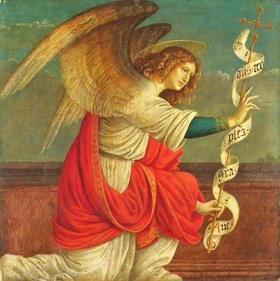
SIRAGUSA TOURS LTD
Art History and Classical Studytours

Newsletter, Winter 2011
Study Tour Programme

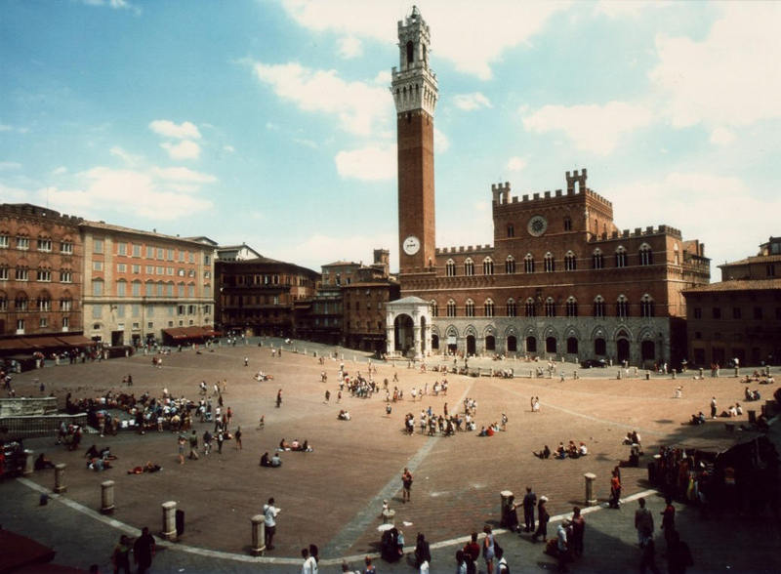 | 1 – 5 March 2012  Siena & San Gimignano: Art and Culture  led by Daphne Joynes  Course Cost £560 (plus flight)  OU related courses: General Interest/AA315/A216  VIABLE, 1 PLACE LEFT
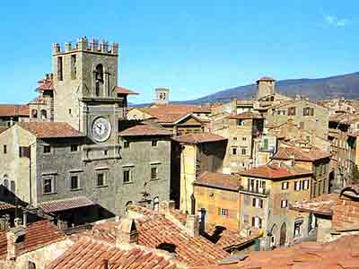 | 6 - 12 March 2012  Cortona, Assisi and Arezzo, half board basis (on 4 of the nights)  Led by Mary Hawkins  Course Cost £870 (plus flight)  OU related courses: General Interest/AA315  VIABLE, MORE PLACES AVAILABLE
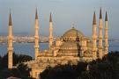 | 19 – 25 April 2012  LRAC Istanbul  Led by Dalila Castelijn  Course Cost LRAC members £725, non-members £745 (plus flight)  OU related courses: General Interest  VIABLE, MORE PLACES AVAILABLE
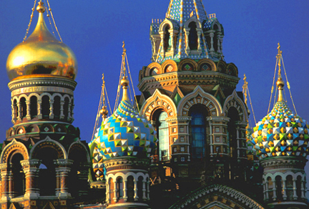 | 10 – 15 May 2012  St Petersburg  Led by Mary Hawkins  Course Cost £895 (plus flight and VISA)  OU related courses: General Interest  VIABLE, MORE PLACES AVAILABLE
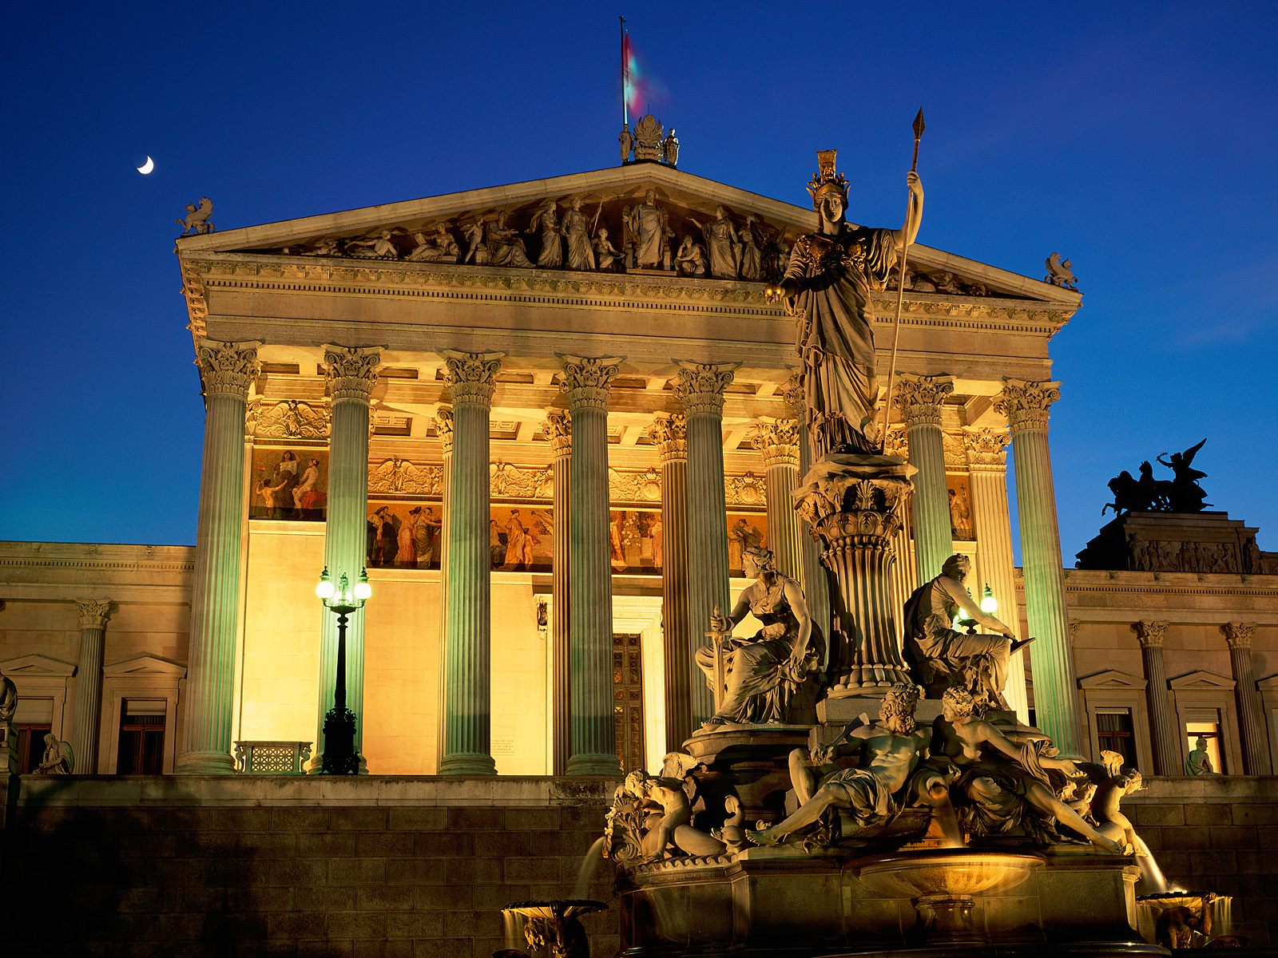 | 24 – 28 May 2012  Vienna  Led by Jackie Parry  Course Cost £575 (plus flight)  OU related courses: General Interest
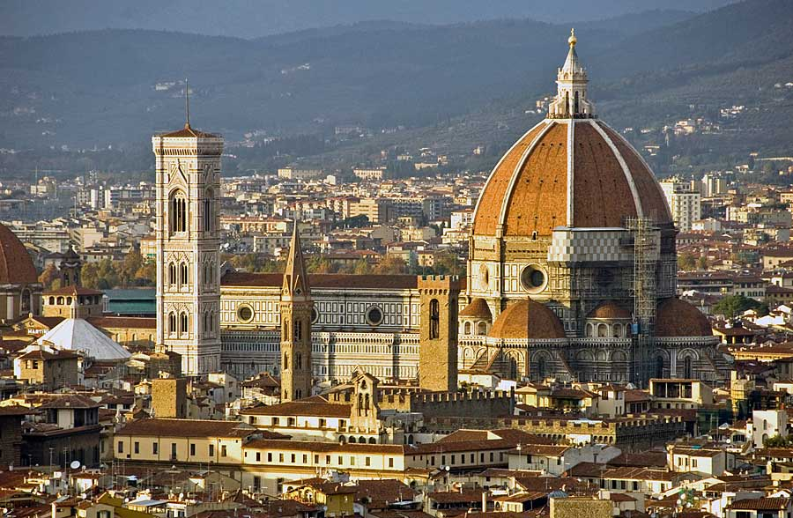 | 2 – 7 June 2012  Florence and Siena  Led by Jackie Parry  Course cost £565 (plus flight  OU related courses: AA315/A216/General Interest
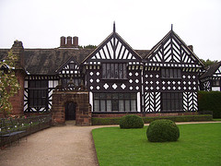 | 28 June – 1 July 2012  Liverpool  Led by Jackie Parry  Course Cost £315 (plus train)  OU related courses: General Interest/A216/AA315
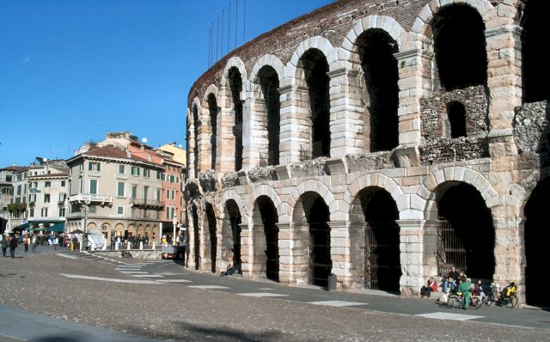 | 6 – 11 September 2012  Trento and Verona  Led by Dalila Castelijn  Course cost £645 (plus flight)  OU related courses: General Interest/AA315/Classics
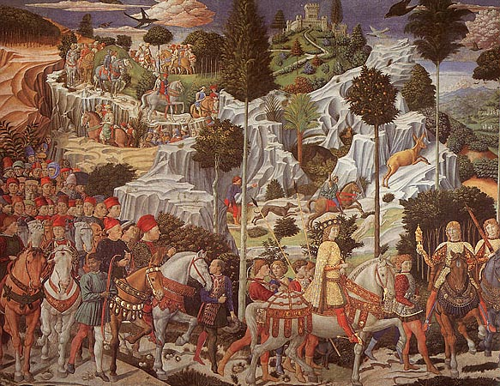 | 29 October – 3 November 2012  Renaissance Florence and Fiesole  led by Daphne Joynes  Course Cost £545 (plus flight)  OU related courses: AA315/A216/General Interest
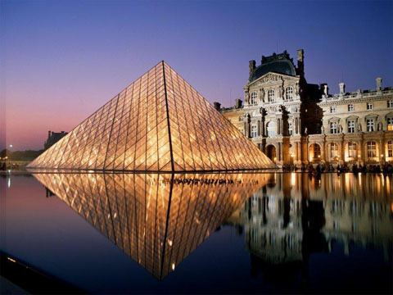 | 16 - 19 November 2012  Paris: Modern Art  led by Jackie Parry  Course Cost £545 (including Eurostar)  OU related courses: AA318/A216/General Interest

NEW GALLERY VISIT, 5th May 2012, British Museum, led by Dr William Sterling
Medieval to Modern: Changes in Techniques and Subjects
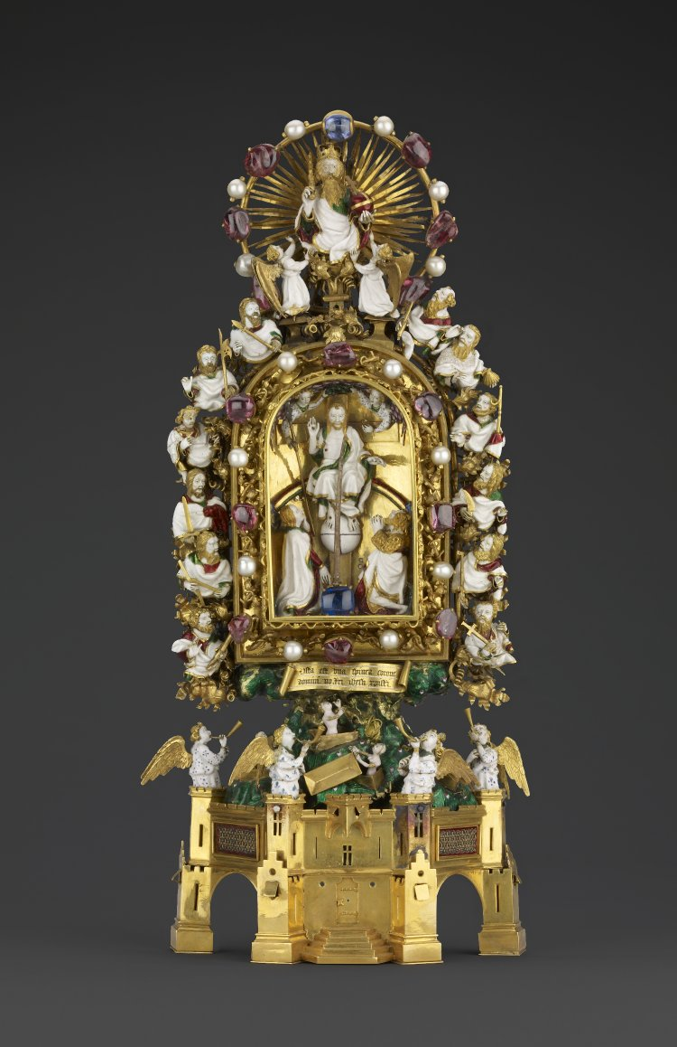
The British Museum contains some of the finest examples of craftsmanship from Mediaeval and Modern Europe. This tour covers developments in enamelling, glass decorating, ceramics and other media from the late Mediaeval period to about 1900. Enamelling includes two of the few surviving examples of works commissioned by the Duc de Berry, the Royal Gold Cup and the Holy Thorn Reliquary plus examples of painted enamel by Leonard Limousin, one of the most celebrated of all Renaissance enamellers and a late nineteenth century set of Five Senses by Eugene Richet. The glass includes Italian examples from the fourteenth and sixteenth centuries and the ceramics cover the whole period showing the development from Mediaeval tiles through Italian maiolica to the porcelain inspired by Chinese imports and Victorian tiles inspired by the Mediaeval ones. Other materials looked at will include wood, gold, ivory and gems.

NEW DESTINATIONS
Trento and Verona, 6 – 11 September 2012, led by Dalila Castelijn. Contact us for details or have a look on our website .
Malta, 21 – 26 November 2012, led by Mary Hawkins. Details are almost ready and will be sent automatically to those people who have already expressed interest. If you are interested and haven’t contacted us yet, please do so now.
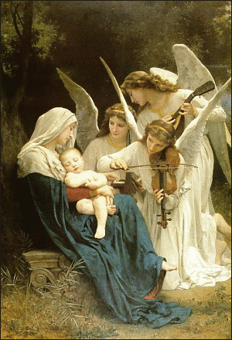
In January or February 2013 there will be tour to Egypt, led by Dalila Castelijn. Further information will be available in our next Newsletter.

SEASONAL WISHES

I would like to take the opportunity to wish you all a wonderful, peaceful and joyous Christmas and a blessed New Year filled with excitement and wonderful opportunities.
Franziska Siragusa

Gallery and Museum Visits

28 Jan 2012 | Making Renaissance Art: Craftsmanship and Technique in early Italian Painting, NG | AA315/A216/  A840/General Interest | Daphne Joynes | 11:00 – 13:00 | £17.50
11 Feb 2012 | From Early to High Renaissance: Continuity and Change in Italian Painting, National Gallery | AA315/A216/  A840/General Interest | Daphne Joynes | 11:00 – 13:00 | £17.50
18 Feb 2012 | Renaissance Altarpieces, National Gallery, London | AA315/General Interest | Mary Hawkins | 11:00 – 13:00 | £17.50
18 Feb 2012 | Netherlandish Painting, National Gallery, London | AA315/General Interest | Mary Hawkins | 14:00 – 16:00 | £17.50
10 March 2012 | The Wallace Collection: An International Treasurehouse (18th Century French Painting) | A216/General Interest | Jackie Parry | 11:00 – 13:00 | £17.50
10 March 2012 | Impressionism, National Gallery London | AA318/General Interest | Jackie Parry | 14:30 – 16:30 | £17.50
24 March 2012 | Different Views of Art: Patronage in Italy Outside Florence  National Gallery, London | AA315/A216/  A840/General Interest | Daphne Joynes | 11:00 – 13:00 | £17.50
21 April 2012 | Topics for Projects and Independent Essays,  National Gallery, London | AA315 | Daphne Joynes | 11:00 – 13:00 | £17.50
28 April 2012 | Victorian Painting, Tate Britain, London | A216/General Interest | Jackie Parry | 11:00 – 13:00 | £17.50
28 April 2012 | PreRaphaelite Brotherhood, Tate Britain, London | A216/General Interest | Jackie Parry | 14:00 – 16.00 | £17.50
5 May 2012 | Medieval to Modern: Changes in Techniques and Subjects, British Museum, London | General Interest /A200 | Dr William Sterling | 11:00 – 13:00 | £17.50
12 May 2012 | Cubism to Abstraction, Tate Modern, London | A216/AA318/General Interest | Jackie Parry | 11:00 – 13:00 | £17.50
12 May 2012 | New, Newer, Newest: Conceptualism and After, Tate Modern, London | A216/AA318/General Interest | Jackie Parry | 14:00 – 16:00 | £17.50
26 May 2012 | Fascinating Faces: A Study of Portraits, National Gallery, London | General Interest/A216 | Mary Hawkins | 11:00 – 13:00 | £17.50

TUTORS: The tutors for these Gallery and Museum Visits are all experienced Lecturers who have been selected for their skills in communication and teaching. They are able to direct attention to study issues whether at an introductory or advanced level. Siragusa Tours Ltd reserves the right to substitute a named tutor. Tutors/Lecturers will be identified by a badge/sheet displaying their name.

GROUP SIZE: For Gallery/Museum Visits the number of participants will usually be no more than 15. This is to ensure the maximum benefit for all participants.

CANCELLATIONS: If Siragusa Tours Ltd is obliged to cancel a particular Gallery/Museum Visit, a full refund will be made. If you are unable to participate and cancel before the event you will receive a voucher to be used at another similar event or you can choose an alternative visit.

MEETING POINTS FOR GALLERY VISITS
National Gallery: ‘Meeting Point’ beside the Information Desk in the Sainsbury Wing
National Portrait Gallery: By the entrance
V&A: Group Entrance in Exhibition Road
Courtauld Institute (Somerset House, The Strand): Under portico outside gallery entrance
Tate Modern: In the Turbine Hall by the Information Desk
Tate Britain: Manton group entrance on Atterbury Street
British Museum: In the Great Court by the Information Desk
Estorick Collection: By the entrance

Siragusa Tours Ltd, Unit 26, JBJ Business Park, Northampton Rd, Blisworth, Northants NN7 3DW
Tel 01604 859491 Fax 01604 858511 info@siragusatours.co.uk www.siragusatours.co.uk

----------------------------------------------------------------------------------------------------------------------------------------------
Gallery and Museum Visits Booking Form

Mr/Mrs/Ms
Address
 |  | Post Code
Phone | Mobile
E-mail
OU Course(s)
Date | Time | Location | Course | Places | Total
 |  |  |  |  | £
 |  |  |  |  | £
 |  |  |  |  | £
 |  |  |  |  | £
 |  |  |  |  | £
 |  |  |  |  | £
 |  |  |  |  | £

I enclose a cheque made payable to Siragusa Tours Ltd for £

