***SIRAGUSA TOURS LTD***

*Art History and Classical Studytours*

*Newsletter, May 2018*

**Study Tour Programme**

|  |  |
| --- | --- |
| http://3.bp.blogspot.com/-Q9X4QrtXRxY/VcD_4voCgvI/AAAAAAAAC-k/cMo7AWdiUsE/s1600/Alberobello2.jpg | 15 – 21 May 2018  **Puglia and its Legacy of Art and Architecture**  Led by Dalila Castelijn  Course Cost £820 (plus flight)  OU related courses: A226/General Interest  **Viable** |
| C:\Users\Amministratore\AppData\Local\Microsoft\Windows\Temporary Internet Files\Content.Outlook\UQZO48C0\2013-05-28 15-48-12 IMG_2311 (2).JPG | 16 – 19 July 2018  **Hadrian’s Wall – LRAC Tour**  Led by Cathy Mercer  Course Cost £299 (plus travel)  OU related courses: General Interest/A340 Roman Empire/A219 Introduction to the Classical World  **Fully booked (you can request to be put on the waiting list)** |
| C:\Users\Amministratore\AppData\Local\Microsoft\Windows\Temporary Internet Files\Content.Outlook\UQZO48C0\IMG_1765 (2).JPG | 18 – 23 October 2018  **Athens and Thessaloniki: Masterpieces of Byzantium**  Led by Peter Murphy  Course Cost £660 (plus travel)  OU related courses: General Interest  **Viable and more places available** |
| https://c1.staticflickr.com/9/8154/7422589176_14f203fa88_b.jpg | 21 – 26 November 2018  **Stockholm**  Led by Jackie Parry  Course Cost £690 (plus flight)  OU related courses: All Art History Courses and General Interest  **Viable and 3 more places available** |
| http://i.dailymail.co.uk/i/pix/2011/10/25/article-2053363-0E508FD200000578-201_634x424.jpg | 3 – 6 December 2018  **Bologna**  Led by Daphne Joynes  Course Cost £399 (plus flight)  OU related courses: AA315/A226/General Interest |
| http://tajikembassy.at/_ph/3/66840175.jpg | 4 – 8 April 2019  **Vienna**  Led by Mary Hawkins  Course Cost £615 (plus flight)  OU related courses: General Interest |

***New Tours for 2019***

*Philadelphia, 9 – 14 May 2019, led by Jackie Parry*

*Lisbon, 5 – 10June 2019, led by Dalila Castelijn*

*Roman Cumbria, 8 – 12 July 2019, led by Cathy Mercer*

*Val Camonica, end of September, led by George Nash*

*Dresden, beginning of October, led by Jackie Parry*

*Crete or Rome, end of October, led by Peter Murphy*

***BOLOGNA, 3 – 6 December 2018***

***Led by Daphne Joynes***

**Description**

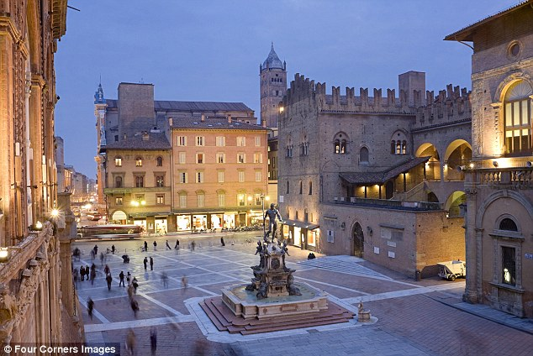**BOLOGNA** is a bustling city of elegant porticoes and piazzas, medieval towers, palaces and churches, and is one of the most beautiful of Italy’s historic cities – particularly as is prepares for Christmas! Its university, which was founded in 1088, is the oldest in Europe.

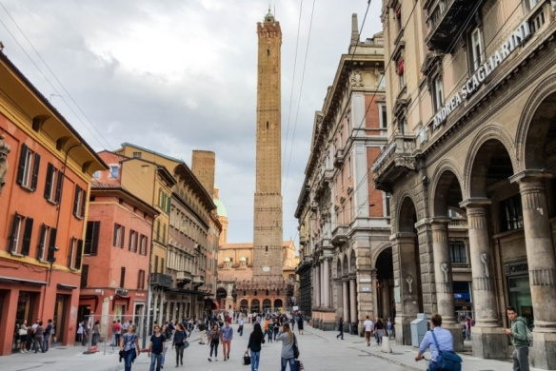 Art thrived in Bologna throughout the 15th century under the rule of the wealthy Bentivoglio family, and painters from all over Italy were attracted to the city during this period. In the 16th century the Bolognese School of [painting](http://en.wikipedia.org/wiki/Painting) flourished and for a time the city rivaled [Florence](http://en.wikipedia.org/wiki/Florence) and [Rome](http://en.wikipedia.org/wiki/Rome) as a centre of painting.

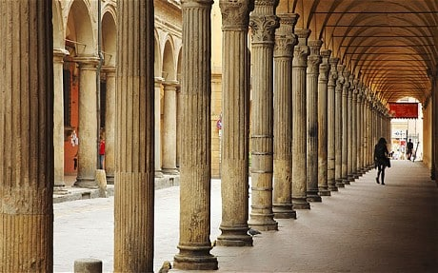 The Pinacoteca houses an important collection of works by leading artists of the Bolognese School including Annibale, Agostino, Lodovico Carracci, Guercino and Domenichino, along with works by Giotto, Raphael, Francesco del Cossa, Perugino and many others. And the city’s churches are home to sculptural works by leading Italian sculptors - including Michelangelo, Jacopo della Quercia, Giambologna and Nicola Pisano.

We will be in Bologna for 4 days, and so there will be plenty of time to get to know Renaissance Bologna and to enjoy the wonderfully cosmopolitan atmosphere of its markets, restaurants, piazzas, and stunning shops.

***We need a few more bookings for this tour to become viable, let us know if you are interested.***

**Gallery and Museum Visits in London**

**The Switch House**

**Saturday, 2 June 2018, 11.00 – 13.00 hrs, with Jackie Parry, £17.50**

Opening on the 17th June 2016 The Tate's new £260m extension has 3 new levels of galleries above The Tank which house contemporary art on a changing basis, taking over where The Boiler House ends.  These works can be challenging and  are mostly freed from the usual plinths and barriers and can be walked around and fully engaged with. There is also a viewing platform on the 10th floor.

(Meeting Place will be in the Turbine Hall by the Information Desk)

**TUTORS:** The tutors for our Gallery and Museum Visits are all experienced Lecturers who have been selected for their skills in communication and teaching. They are able to direct attention to study issues whether at an introductory or advanced level. Siragusa Tours Ltd reserves the right to substitute a named tutor. **Tutors/Lecturers will be identified by a badge saying SIRAGUSA TOURS and displaying their name.**

**GROUP SIZE:** For Gallery/Museum Visitsthe number of participants will usually be no more than 16. This is to ensure the maximum benefit for all participants.

**CONFIRMATIONS**: After you have booked on a gallery visit you will receive a confirmation letter with instructions and telephone numbers of the tutors in case you need to contact them on the day.

**CANCELLATIONS:** If Siragusa Tours Ltd is obliged to cancel a particular Gallery/Museum Visit, a full refund will be made. If you are unable to participate and cancel before the event you are entitled do choose an alternative visit.

**LATE ARRIVAL**: If you arrive late please ask at the information desk about the whereabouts of the group.

**MEETING POINTS FOR GALLERY VISITS**

**National Gallery**: by the **bench opposite** the Information Desk in the Sainsbury Wing

**National Portrait Gallery**: By the entrance

**V&A**: by the Main Entrance Hall

**Courtauld Institute (Somerset House, The Strand)**: Under portico outside gallery entrance

**Tate Modern**: In the Turbine Hall by the Information Desk

**Tate Britain**: Manton group entrance on Atterbury Street

**British Museum**: In the Great Court by the Information Desk

**Estorick Collection**: By the entrance

**Wallace Collection:** By the entrance

**William Morris Gallery** (Lloyd Park, Walthamstow, London): By the Entrance

**John Soane Museum**: By the entrance

***Gallery and Museum Visits Booking Form***

|  |  |  |
| --- | --- | --- |
| Mr/Mrs/Ms | | |
| Address | | |
|  | | |
|  | | Post Code |
| Phone | Mobile | |
| E-mail | | |
| Are you an OU Student? YES / NO OU Course(s) | | |

|  |  |  |  |  |  |
| --- | --- | --- | --- | --- | --- |
| Date | Time | Location | Course | Places | Total |
|  |  |  |  |  | **£** |
|  |  |  |  |  | **£** |
|  |  |  |  |  | **£** |
|  |  |  |  |  | **£** |
|  |  |  |  |  | **£** |
|  |  |  |  |  | **£** |
|  |  |  |  |  | **£** |

I enclose a cheque made payable to **Siragusa Tours Ltd** for £

Siragusa Tours Ltd, Unit 26, JBJ Business Park, Northampton Rd, Blisworth, Northants NN7 3DW

**Tel 01604 859491 Fax 01604 858511** [**info@siragusatours.co.uk**](mailto:info@siragusatours.co.uk)[**www.siragusatours.co.uk**](http://www.siragusatours.co.uk)